Major Investigations, New (and Revised) Thinking Ahead
By Robert M. MacIntosh Jr. (LM0996), Chief Advisor, International Safety Affairs, National Transportation Safety Board, Washington, D.C., USA

Robert MacIntosh has a long career in the aviation industry, including NTSB investigator-in-charge, airline director of safety, airplane manufacturer staff engineer/accident investigator, and 22 years as a U.S. Air Force officer pilot and safety director. He has more than 8,000 hours of flying experience and holds bachelor of arts and master of business degrees.

Being successful in any business endeavor calls for constant review and revision of processes and technology. There is no exception to this premise in the global aviation environment. To remain current and relevant, the time-honored practices of aircraft accident investigation need constant revision. The journeyman air accident investigators of today can quickly find themselves rendered noncurrent by the technical, organizational, and political advances of tomorrow. As the reliability of our airframes, powerplants, and infrastructure has improved, the perspective of our accident investigation focus has certainly shifted. In past decades, operators could expect an engine failure about every 1,000 hours of operation. Avionics components had even shorter time between failures. Thankfully, those times are past, and today’s challenges result in a more proactive approach aligned with safety management concepts and a much more broad and effective approach toward risk identification and reduction. So where will the wings of change take formal investigations and the practicing air safety investigators in the future?

Data—the insatiable quest
One place to look at NextGen ideas and new thinking is in the area of recorded data. With the preponderance of data available from the multiple parameters on aircraft flight recorders and the data further available within the non-volatile memory (NVM) of various components and subsystems, how much time and effort do the investigators really need to exert on scene? How much on-site documentation is enough? Can we expect to effectively investigate major accidents with the recorded data alone? I would offer that the answer to that premise is a very qualified perhaps, maybe, sometimes! We can cite some past cases where the wreckage is still up on the mountain or down on the seabed. Events in the 1990s, such as the Thai Airways A310 near Kathmandu, Nepal, or the Berginair B-757 off the north coast of the Dominican Republic, are examples of the ability of the air investigation team to proceed toward reliable conclusions and recommendations without (lacking) the on-scene documentation.

However, for the purposes of the ISASI 2011 seminar theme, “Investigation—A Shared Process,” it is appropriate to introduce a situation where existing data alone did not allow the investigation team to arrive at substantive conclusions. I refer to the seemingly ample quantity of information available to investigate the 17 January 2008, B-777-200ER, British Airways accident at London-Heathrow Airport, United Kingdom. The UK Air Accidents Investigation Branch (AAIB) did a tremendous job providing details of the ongoing investigation through their interim reports and a superb final report published in January 2010. Many of the details of the AAIB investigation were presented at the ISASI 2010 annual seminar in Sapporo, Japan, in papers by Senior Inspector Brian McDermid, “Heathrow 777,” regarding the extensive fuel system testing, and by Senior Inspector Mark Ford, “Investigative Data Mining,” regarding the challenges presented by that evidence. It is that preponderance of evidence that should be notable to all of us involved in the investigation of accidents and incidents in large transport aircraft.
The B-777 was certificated in April 1995. It is equipped, per ICAO Annex 6, with an extensive list of flight recorder parameters derived from fly-by-wire mediated flight and engine controls. Since its entry into commercial service, the B-777 fleet accumulated more than 17 million accident-free flight hours over more than 12 years prior to this hull loss. Also, regarding data available in the Heathrow event, recall the aircraft remained relatively intact at the end of Runway 27L, all the crew and passengers survived, there were many credible witnesses, and data were available from both of the required onboard flight recorder systems, from a QAR quick access recorder, and from the air traffic and ground servicing organizations.
The UK AAIB Final Accident report provides a clearly worded probable cause of the event—when the engines ceased responding to commands for increased power, the formation and sudden release of ice in the fuel delivery pipes caused a restriction at the engine fuel oil heat exchangers (FOHE) during the critical landing stage of the flight. But did the data alone lead the AAIB to that probable cause?
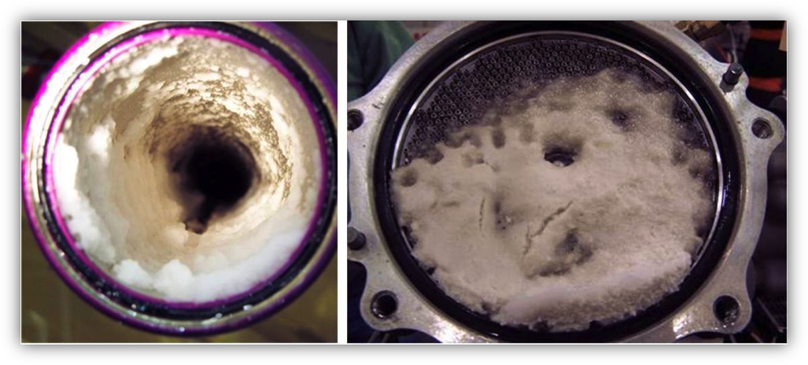
Figure 1: Fuel tube and FOHE ice.

I would suggest that many more resources and expertise went into that investigation: the field investigation, the component examinations, the interim actions for airline operators, the engineering testing and analysis, and, of course, the final report and safety recommendations. Most will agree that this extensive and detailed work was necessary to make the whole investigation process and results credible to the professional aviation community and the public. And further, we should ask ourselves, as state investigation authorities and industry investigation professionals, How we can best be prepared for any similar such an undertaking in the future? For this accident, though, the vast amount of data that were available both from the accident airplane and from thousands of other flights led investigators to develop a hypothesis about what occurred in this accident.
Within the UK AAIB, the air safety investigators recognized a need for some very specific expertise. It fell to a group of statisticians with the support of the air safety investigators to determine what may have been unique about this accident flight from those millions of accident-free flights that took place over the prior 12 years.
AAIB Senior Inspector Mark Ford tells us in the ISASI Forum article, “Investigative Data Mining,” that their group got an early start with immediate access to the operator's flight data monitoring (FDM) of 13,500 flights, and the data mining team eventually incorporated minimum fuel temperature snapshots from 191,000 flights from northern hemisphere, tropics, and southern hemisphere based on many operators’ data.
The purpose of this current discussion is not to review the details of data mining provided in the AAIB’s investigation, but rather to recognize the initiative taken by the AAIB to rally together the wide-ranging sources of FDM data in order to analyze and share that data in a meaningful way. There is industry consensus that this data mining initiative provided an important catalyst leading to full understanding of the event. Further, it should be noted that similar data mining strategies may very well be the NextGen thinking required for future serious and complicated investigations.
Are you ready to “data mine”? Can you (or your investigation agency) arrange for access to very privately held FDM data? Can you analyze it for your specific purposes and at the same time protect it from unauthorized users—such as overzealous or misguided judicial advocates? To clarify, the subject is raw data, not summarized or aggregate information derived from raw data. And the question posed is, Can your investigation get timely access to all the data that may sometimes be needed in a complicated investigation, similar to the data analyzed by the AAIB? An investigator’s need for such raw data may very well be the NextGen challenge for the air safety investigators of tomorrow.

Testing—collaborative efforts
Another investigative vignette from the Heathrow event that deserves special recognition within our investigation community is the fuel rig testing. How did the investigation replicate the conditions of the accident to confirm their hypothesis that there were some unique factors of the flight that contributed to the formation of ice in the fuel pipes and then contribute to the subsequent release of a quantity of ice (slush) in the fuel delivery stream? As many of our ISASI membership have seen, just like the carburetor ice conditions of the general aviation fleet, the suspect ice obstruction/restriction usually seems to have melted before the arrival of the inspector to see the evidence.
That lack of physical evidence provides an opportunity to review the details of the trail toward a final decision to test a major portion of the airplane fuel system. We know now that the B-777 has more than 110 feet of fuel tubes and lots of turns and twists valves, filter units, and a Fuel Oil Heat Exchanger unit (FOHE) that makes up the complete system in the tank to engine setup. There was hardly an investigator on the planet who did not suspect fuel system icing from some source as they read the initial details of the BA accident—but where to look?
AAIB Senior Inspector Brian McDermid, in his article in the ISASI Forum, “Heathrow 777—Investigation Challenges and Problems,” presents a fascinating story of starting out thinking that small-scale laboratory testing would be sufficient. Then there was a consideration for the possibility of flight testing, and further consideration for the use of a full-scale climatic hangar with either a single pass of fuel or with a reticulating source of fuel. Finally, a decision was made to assemble a full-size test rig with components of the crashed airplane at the North Boeing Field facility in the U.S. The UK AAIB and participating agencies came to this highly engineered and costly conclusion, that an “iron bird” test rig was needed, in order to accurately replicate the mechanical and environmental conditions and to ensure that credible results would be fully available for all aviation industry stakeholders.
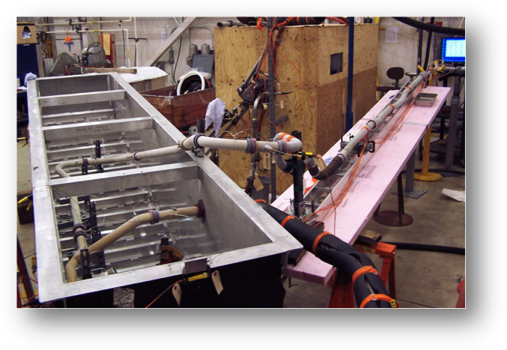
Figure 2: Test rig.

At this point, it is appropriate to mention the broad-based aviation industry cooperation and communication that was necessary to make this endeavor fully representative of the flight conditions. Recall that the Boeing 777 has an option for engine installations offered by all three large engine manufacturers, Rolls Royce, Pratt & Whitney, and GEAE. Also note that the Trent engine involved in the Heathrow event is also installed on both Boeing and Airbus transport airplanes. One can easily see the broad scope of industry interest in such a complex investigation. Further, as state investigative agencies, we probably should conclude, with our limited agency resources, that we cannot conduct such complex investigations alone. Although ICAO Annex 13 standards and recommended practices place the State of Occurrence in the leadership position and in full control and responsible for air accident investigations, without the other participating partners an investigation of this magnitude cannot move forward without the collaborative knowledge and collective resources of other investigative agencies and industry. To do anything less is to create a credibility gap that would do a disservice to all involved. Further, any muted effort could stop well short of the desired goals to identify the causal factors and mitigate the safety risks.
The results of the Heathrow investigation are well known. Following an in-depth analysis of the occurrence by all participating agencies, with major participation from the engine and airframe manufacturers, the FAA issued an airworthiness directive (AD), effective September 29, 2008, for interim mitigating actions to prevent recurrence. On-ground fuel circulation procedures were introduced along with inflight high thrust fuel circulation procedures prior to descent. This AD was superseded in March 2009 with some limited modifications, and, concurrently, a subsequent engineering improvement was designed for the Trent FOHE. The AAIB final report also contained safety recommendations to FAA and EASA authorities to undertake joint research to identify the root causes of fuel system icing that should encompass the airframe, the engine, and the environment in order to address future aircraft design and certification requirements.
What is the takeaway from these unique experiences of the Heathrow B-777 investigation? Ask yourself, does your agency (and state) have the capability to investigate a complex accident event? Are you prepared to offer sufficient elements of trust to those outside your close sphere of control? Will the independence of the investigation allow you to reach out for similar additional expertise? Are you able to recognize the parallel air safety interests of those other concerned participants? Can a sufficient level of trust be cultivated between government and industry representatives to go forward in a productive arrangement to share FDM data? Are you prepared and functionally able to put mechanisms in place to meld these common interests? To repeat—these are the NextGen challenges for the air safety investigators of tomorrow.

Civil/military issues—seeking data in a unique crossover case
In keeping with the ISASI 2011 theme, “Investigation—A Shared Process,” it is appropriate to direct our attention to a recent example of civil/military cooperation in the field of investigation. Regardless of which side of the industry you currently reside, hopefully you will find an element of takeaway that may apply to your own experience. Here, I will highlight an accident that occurred on 10 April 2010 to a Tu-154M, Polish Air Force (PAF) flight providing transportation for the president of the Republic of Poland and a party of distinguished visitors. The military mission was to deliver a group of military and civilian dignitaries and their wives, politicians, businessmen and clergy, to a ceremony in the Russian Federation at a memorial complex intended to heal some of the wounds of World War II. The destination was Smolensk “Severny” airfield, a military facility slightly more than one hour from Warsaw. The mission ended in a very tragic controlled flight into terrain (CFIT) scenario just 600 meters short of the destination runway. All 88 passengers, 5 cabin crew, and 3 flight crew were fatally injured. As might be expected, old political wounds resurfaced along with the turmoil from the death of the president of the Republic of Poland and many of the leading cabinet members, military hierarchy, and social and political leadership.
Of interest to ISASI members is what happened next. What agency would investigate the crash of a Polish Air Force VIP transport aircraft within the territory of the Russian Federation? This was a “state aircraft,” clearly outside the ICAO Convention definition of civil air transport activity. The bilateral diplomatic agreement authorizing the military mission did not address the eventuality of accident or incident and there was no provision for insurance coverage of the passengers.
Upon notification of the crisis, the president of the Russian Federation provided an initial response at the accident site supervised by the head of the Flight Safety Agency of the Russian Armed Forces. However, from the onset, it was obvious to all concerned that, in this very highly charged atmosphere, the traditional military leaderships should not be in a position to investigate themselves.
With some astute diplomacy on both sides, three days following the accident, both governments concluded a bilateral agreement that the Russian Federation Interstate Aviation Committee (IAC) would conduct the investigation in accord with the existing ICAO Annex 13 standards and recommended practices. Acting as the State of Occurrence, the IAC appointed an investigator-in-charge and the Polish government appointed an accredited representative within the protocols of the State of the Operator and State of Registration. The Polish Air Force participated as an advisor to the accredited representative of Poland.
The various participants formed the traditional investigation groups and set about to investigate the accident at the crash site and also at the Warsaw dispatch point and crew base. Early readout of the CVR indicated conversations related to the setup of a flight management system (FMS), and several audible warnings could be heard from a Terrain Alert Warning System (TAWS) prior to the crash. The FDR readout indicated that, for most of the flight, the autopilot was engaged and coupled in lateral navigation mode with the FMS. Evidence from the accident site identified the FMS and TAWS components as manufactured by Universal Avionics Systems Corporation of Redmond, Wash., U.S.A. A maintenance records examination confirmed these units had been installed as an upgrade of the PAF Tu-154 fleet. The investigator-in-charge notified the U.S. National Transportation Safety Board (NTSB) of the U.S.-manufactured and certificated navigational equipment and requested U.S. participation in the investigation. Ultimately, despite significant mechanical damage, with the assistance of the design and manufacturing engineers, most of the non-volatile memory data were retrieved at the manufacturing facility. Several important crew actions were discovered through this examination and analysis of the FMS and TAWS and conventional flight recorders that led the investigation to the following general conclusions:
* The FMS terrain database did not contain data for the Smolensk “Severny” military airfield. The crew constructed an approach in the FMS using waypoints superimposed on the physical location of the published 2 RBN approach procedure.
* The weather was below minimums upon arrival, and the crew requested and was approved to conduct a “trial” approach to the published minimum of 100 meters.
* The crew flew the approach with the autothrottle and autopilot engaged in lateral nav mode and used the autopilot climb/descend wheel for the glide path.
* The crew continued descent below the published minimums and took no action in regard to the TAWS terrain alerts and warning—ultimately colliding with trees and terrain in a valley before the runway threshold. The aircraft was destroyed. All aboard were fatally injured as a result of deceleration, blunt force trauma, and destruction of structure.
* Further, the presence and discussions in the cockpit during the approach of the commander–in-chief of the Polish Air Force and the protocol director of the Polish government influenced the crew to continue the approach in conditions of unjustified risk.
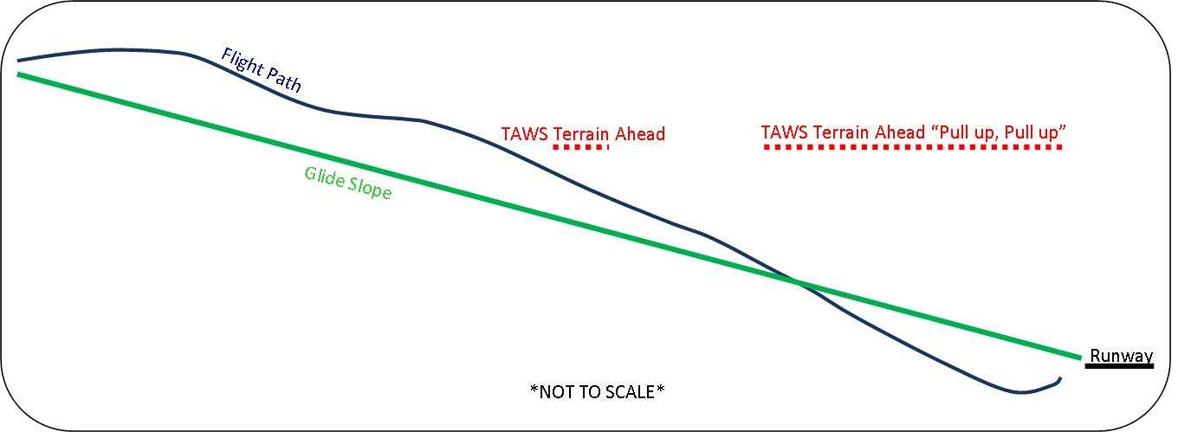
Figure 3: Glide slope versus flight path.

The investigation was completed in January 2010 (nine months following the occurrence) and the final report and supporting documents are available to the public and posted on the IAC website. The intent of this brief résumé of the accident is to illustrate to the ISASI membership, the necessity of the IAC investigation group to gather much more information than was available on the flight recorders. This action is not always prudent or appropriate in every case due to the labor intensive process requirements. However, in order to fully understand this scenario, it was necessary to proceed in much more expanded detail to determine the navigation performance of the FMS and the warning capabilities of the TAWS. This effort required what we should call “the physical presence test.” That is, the investigators traveling directly to the component manufacturing facility, jointly developing an investigation protocol, and proceeding to examine each sub component and circuit board to extract the bits of data necessary to understand the overall component function and performance. What does this action say to you and your fellow investigators? Are you prepared, when necessary, to identify equipment with non-volatile memory sources and seek out methods to extract raw data? Are you willing to invest the time and resources for forensic component examination. And on the other hand, are you capable and willing to determine when it may be sufficient for practical purposes to terminate searches that may appear to waste resources and delay timely conclusions? To repeat—these are the NextGen challenges for the air safety investigators of tomorrow.

The sharing process—overcoming obstacles
Again recognizing the ISASI 2011 seminar theme, “Investigation–A Shared Process,” it is appropriate to address the issues of sharing proprietary data and the obstacles that one meets in attempting to accomplish that end. As an example, a multifaceted case involving different nation states can best illustrate the difficulties presented to an investigator-in-charge.
On 7 October 2008, an Airbus A330-300 operated by Qantas Airways departed Singapore enroute to Perth, Australia. On board were 303 passengers, 9 cabin crew, and 3 flight crew. While in cruse flight at Flight Level 370, the autopilot disconnected. At about the same time there were various aircraft system failure indications. While the crew was evaluating the situation, the airplane abruptly pitched nose down. The airplane reached a maximum pitch angle of about 8.4 degrees nose down and descended 650 feet during the event. After returning the airplane to the assigned flight level, the crew commenced actions to deal with multiple failure messages. About three minutes later, the airplane began a second uncommanded pitch-down event. The airplane reached a maximum pitch angle of about 3.5 degrees nose down and descended about 400 feet during the second event. One flight attendant and 11 passengers were injured during the upset event. The Australia Air Transportation Safety Board (ATSB) initiated an investigation and quickly identified two significant safety factors related to the pitch-down movements. First, immediately prior to the autopilot disconnect, air data inertial reference unit (ADIRU) No. 1 started to provide erroneous data (spikes) on many parameters fed to aircraft systems. The other two onboard ADIRUs continued to function correctly. Second, some of the spikes in angle-of-attack data were not filtered by the airplane flight control computers, and those flight management computers subsequently produced the uncommented pitch-down movements.
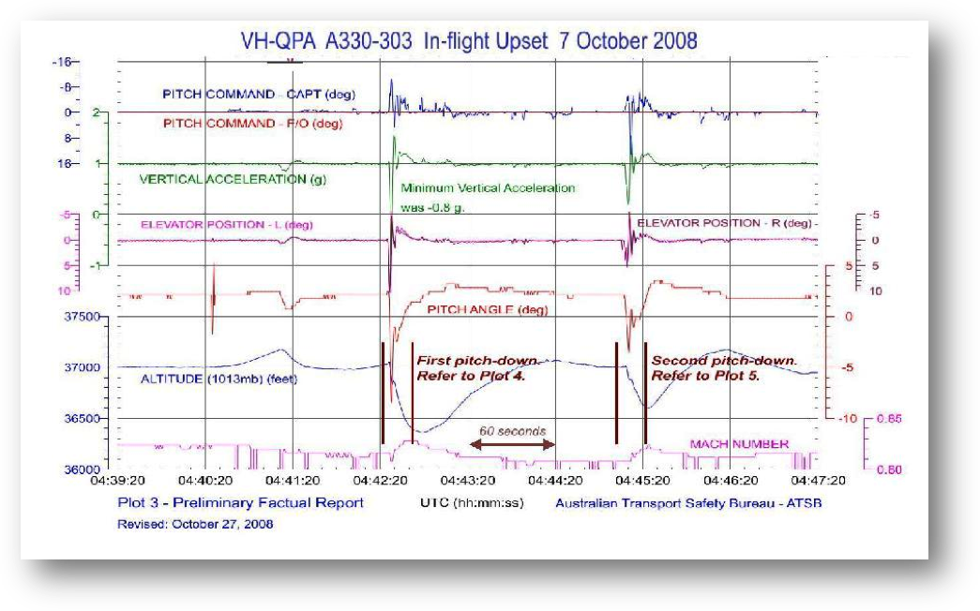
Figure 4: Flight data recorder information.

The ADIRUs were subject to detailed examination and testing at the Northrop-Grumman Corporation facilities in the U.S. The download, examination, and testing were attended by representatives of the ATSB, the French Bureau d’Enquêtes et d’Analyses pour la sécurité de

l’aviation civile (BEA), the U.S. NTSB, the U.S. Federal Aviation Administration (FAA), the airplane manufacturer, and the operator.
Following a preliminary analysis of the occurrence, Airbus published interim operational procedures in the form of an operator information telex to Airbus operators, who were asked to distribute it to all A330/A340/A340-500/A340-600 flight crews without delay. The telex provided brief details known about the occurrence and provided operational recommendations applicable for A330/A340 aircraft fitted with Northrop Grumman ADIRUs. An operations engineering bulletin (OEB) followed, and subsequently the European Aviation Safety Agency (EASA) issued an emergency AD, effective 19 November 2008, to mitigate the potential hazard of a pitch excursion. Similar OEBs were issued by Airbus for A340 airplanes, and an EASA AD followed for the A340.
What is different about this flight path upset event from those of the past? Simply put, the past days of a flight control cable hang-up or a stuck hydraulic servo or iced elevator tab have been overcome by new technology. Today's modern fly-by-wire, computer-assisted flight control systems are highly sophisticated and unique to the manufacturer. Control laws, design concepts, and aerodynamic performance data are generally regarded as trade secrets of a proprietary nature. Each airframe manufacturer’s fly-by-wire concept is a matter of corporate pride and is not something to be readily shared outside the confidence of the manufacturer and the certification authority.
The investigation of the A330 pitch excursion of Qantas Airways was defined as an ICAO Annex 13 “serious incident” by virtue of the personal injuries. The investigation presented some unique challenges in coordination due to a number of multinational participants. The Australian ATSB had the responsibility to conduct an investigation representing the State of Occurrence, Operator, and Registration. As expected, the Airbus A330 brought into the investigation the organizations of Europe, including the Airbus factory team in Toulouse, the BEA, the DGAC of France, and the EASA, the aircraft certification authority in Cologne, Germany. Further, the ADIRUs of the A330 are Northrop Grumman Corporation products, manufactured in the U.S. and certificated to standards set by the FAA. Therefore, U.S. participation included an NTSB accredited representative and advisors from the FAA and Northrop Grumman.
There are additional constraints and legal restrictions in some countries that limit technology transfer on a national level. For example, in the U.S. there are a broad set of regulations that control the import and export of defense articles, technical data, and defense services. These regulations sometimes extend to the participation of foreign entities or import/export of parts, and further, the regulations may extend to target commercial items that can be termed “dual use,” those items having both commercial and military applications. Also, we should note that most countries in the international community maintain foreign policy and national security goals and technology exchange rules that apply to specifically designated countries, regimes, terrorist organizations, illegal traffickers, and other nefarious groups. Although exceptions can be made for certain air safety initiatives, the accident investigation community must operate within the confines of their respective governmental policies.
It is not the purpose of this article to discuss the details of the specific A330 upset event and the causes and safety actions to mitigate risk. The results of the ATSB investigation, the interim reports and the final report are available on the ATSB website. Our purpose is to recognize the international coordination necessary to effect the investigation and to alert our colleagues of the varying organizational needs that may be present in similar future investigations. Setting up foreign travel arrangements or even telephone conferences in this multinational environment presents global management challenges and unique demands on resources. Turning again to the A330 example, in addition to the number of participating agencies already mentioned, it is also appropriate to note the travel distance and time zone differences involved among the participants.

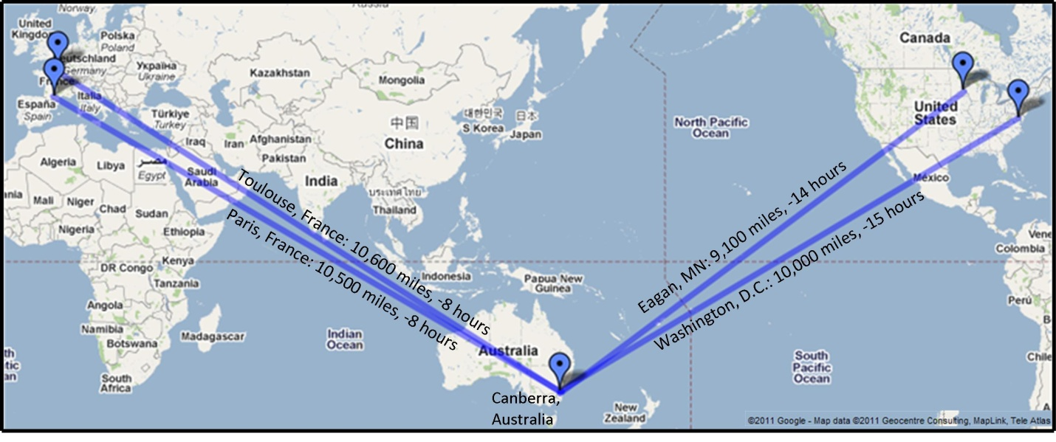
Figure 5: Travel distance and time zone differences between participants.

Once again, we should ask ourselves to consider how best to meld an investigation group to function in the global environment. Do you have an infrastructure in place and ready to address the challenges of distance among participating agencies? Are you prepared to recognize the rationale and impediments of technology transfer concerns? Have you cultivated channels of communications with your foreign relations ministry and diplomatic service departments to be aware of the political issues that may be an obstacle to the investigation? The Qantas upset event serves as an excellent illustration of the added aspects of distance and proprietary data that present the NextGen challenge in multinational investigation management.

Summary—Conclusions, takeaway
There are 190 ICAO member states and, per the ICAO Convention and the standards and recommended practices of Annex 13, each member state is obligated to either investigate accident and serious incident occurrences or to delegate the investigation responsibilities to another state. From the preceding examples, the B-777 of British Airways, the Tu-154 of the Polish Air Force, and the A330 of Qantas Airways, we can observe some exemplar agency accomplishments by the UK AAIB, the IAC of Russia, and the Australian ATSB in the area of investigation and the associated safety recommendations to identify and reduce risks for future flights. As members of the investigative community, are you and your state prepared with the experience and resources to manage or participate in accident/incident investigations similar to the scope and complexity outlined above? If your state does not have the capability to do a complete and credible investigation, do you know where to reach out for necessary guidance and support?
It is appropriate in this ISASI seminar of 2011 to emphasize the NextGen issues of air safety investigation. Hopefully investigators will recognize the wake-up call for greater cooperation necessary to work toward identifying and reducing risk in a timely and efficient manner. Due to the increasing engineering complexity of the aircraft, the availability of additional data sources, the changing human factors operational environment, the global nature of the aviation industry, and the advances of air traffic and airport interface, our future successes in investigation will be measured by how well we can adjust and accept the emerging challenges of mutual trust and support among all participants. Whether the accident/incident event is a four-seat glass cockpit airplane such as the Cirrus model; a new corporate business jet; the new regional entrants from China (Comac), Japan (Mitsubishi), or Russia (Sukhoi); or a large commercial transport airplane from Airbus, Boeing, Bombardier, or Embraer, investigators must be motivated to accept a shift to new realities for data sources and analysis in order to facilitate a timely and efficient investigation and risk mitigation process. This updated approach will require a revised level of trust and professional respect among all participants and an increased reliance on the manufacturing state accredited representative team and the manufacturers’ investigative advisors. Such new and revised thinking is the NextGen challenge for the air safety investigators of tomorrow.

Endnotes

http://www.aaib.gov.uk/publications/formal_reports/1_2010_g_ymmm.cfm.
http://www.isasi.org/docs/Proceedings-2010.pdf or ISASI Proceedings, Volume 14 (ISSN 1562-8914), request from ISASI, 107 E. Holly Ave., Suite11, Sterling, VA 20164-5405 USA.
Photos credit, the Boeing Company.
ISASI Forum, Volume 44, No 2, April-June 2011, pages 5-10.
Depending on the reference source, flight data monitoring (FDM), the proactive use of digital flight data from routine operations to improve aviation safety is also referred to as Flight Data Analysis (FDA) or Flight Operations Quality Assurance (FOQA).
ISASI Forum, Volume 44, No 2, April-June 2011, pages 11-14.
Photo credit, the Boeing Company.
FAA Airworthiness Directive AD 2008-19-04, later superseded March 20, 2009 by AD 2009-05-11. http://rgl.faa.gov/Regulatory_and_Guidance_Library/rgad.nsf/0/7b170a6e13af238a86257570004db7f0/$FILE/2009-05-11.pdf.
Illustrated to simplify data extracted from the IAC final report, Figure 46, as cited below.
http://www.mak.ru/russian/investigations/2010/files/tu154m_101/finalreport_eng.pdf.
http://www.atsb.gov.au/media/51227/AO2008070_prelim.pdf.
Ibid.
Refer to International Traffic and Arms Regulations (ITAR), Export Administration Regulations (EAR), and Office of Foreign Assets Control (OFAC) sanctions programs.
http://www.atsb.gov.au/publications/investigation_reports/2008/aair/ao-2008-070.aspx.
Created with Google Maps.

