Flight Path Analysis based on Video Tracking and Matchmoving

By Major Adam Cybanski
Major Adam Cybanski is the Deputy Promotion and Information at the Canadian Forces Directorate of Flight Safety in Ottawa, Canada. He is a tactical helicopter pilot with over 20 years and 2500 hours on fixed and rotary wing aircraft including the CT114 Tutor, CH139 Jet Ranger, CH135 Twin Huey and CH146 Griffon. He completed a tour in Haiti as Night Vision Goggle Specialist and Maintenance Test Pilot, and has managed the CH146 Griffon Full Flight Simulator. He is a graduate of the Aerospace Systems Course and holds a BSc in Computer Mathematics from Carleton University. .
In the mid 2005s, the flight path analysis, visualization, and crash site documentation capabilities of Canadian Forces Directorate of Flight Safety were limited. Specifically, it was difficult to obtain data on actual aircraft flight profiles without a Flight Data Recorder, and even with the latter, significant analysis was usually required to derive the actual flight path. Animations were challenging to produce. The Directorate of Flight Safety decided in 2009 to sponsor a pilot project within the Directorate to address this deficiency. The purpose of Flight Safety Investigation Technological Upgrade was to employ modern and relatively inexpensive technology towards flight path analysis and visualization, and thus improve upon traditional investigation and promotion methods.

Visualizations of Flight Data Recorder (FDR) flight paths can be used in accident investigation to validate witness testimony, determine flight profiles, calculate ground tracks, harmonize radar data, witness information, and FDR data, and to provide quick and intuitive lessons learned to a much larger audience than just the pilots of the aircraft type. Unfortunately, many aircraft are not equipped with comprehensive FDRs, and only employ Heads Up Display (HUD) or cockpit video to document aircraft flights. A new capability has been developed at the Canadian Forces Directorate of Flight Safety to extract 3D positional data from such video footage through photogrammetry and match moving and employ it in investigative and promotional visualizations.

CT155 Hawk Formation Landing, Sioux Falls SD
This mission was a two ship Hawk formation from Moose Jaw landing in Sioux Falls, SD for fuel. Just prior to flare during the final phase of landing, the number two aircraft flew into the turbulence from the first aircraft. Its wingtip then struck the runway. The aircrew executed an overshoot, declared an emergency, and continued around the traffic pattern for a safe landing.

The CT155 Hawk is not equipped with an FDR, but fortunately a HUD recording of the incident was available (Figure 1). The HUD video could be useful for demonstrating the dangers of wake turbulence in formation, but an animation showing the incident from the chase, top-down, and tower as well as cockpit perspective would better demonstrate the conditions, situation and responses involved in the incident. As a result, this occurrence was chosen for further video analysis.

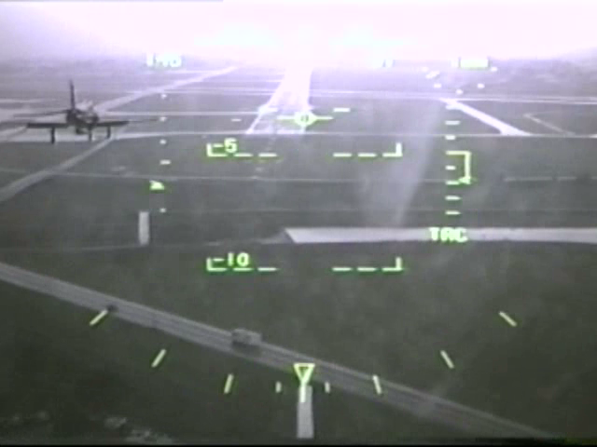
Figure 1 - Original HUD Imagery
Manual Data Extraction from HUD
For each frame of the video, HUD data was reviewed and noted. This included indicated airspeed, heading, altitude, Vertical Speed Indicator (VSI), bank and pitch. The data was read off the scales on the display. The bank indicator has markings at the 0, 5, 15, 30, and 45 degree positions, left and right. Similarly, the pitch is marked in 5 degree increments, and altimeter in 20 foot increments. In order to interpolate between markings, a properly spaced paper scale was produced in order to improve accuracy of the readings. In the case of Figure 2, a reading of approximately -2.2 degrees was made.
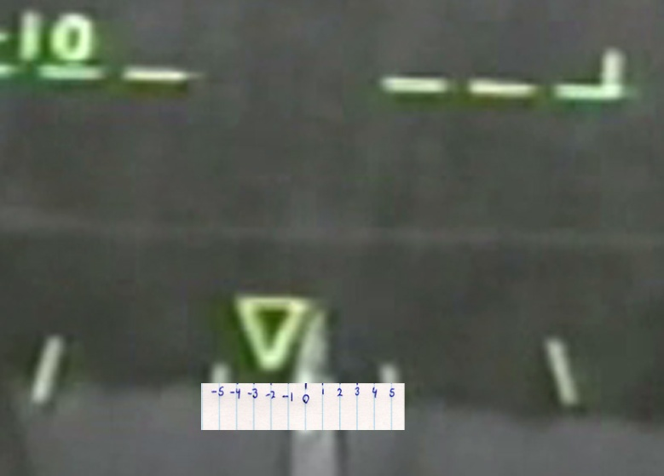Figure 2 - Measuring Bank
Some of the symbology near the top of the video was illegible because of blooming. In this case, the gamma of the image was increased greatly (Figure 3), and the position of the lubber line was measured against the scale.
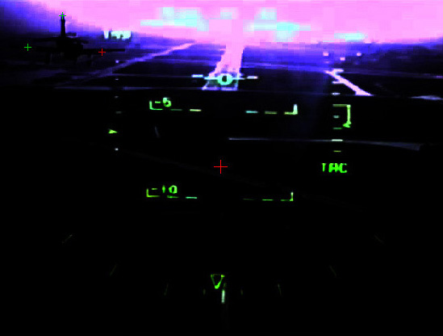Figure 3 - HUD Video Enhancement
The values for airspeed, pitch, bank, heading, altitude, and VSI were recorded for each frame of the video (Figure 4). From these initial values, additional information was derived. The VSI was integrated and compared to the altitude to produce much more accurate and responsive altitude readings. The pitch, bank and heading values underwent exponential smoothing in order to interpolate values for those parameters, as they were displayed on the HUD at different sampling rates. By synchronizing the calculated altitude with the airfield altitude at the moment of touchdown, altitudes were made to match the height above ground, independent of altimeter setting. These altitudes were used in the calculation of outside air temperature throughout the sequence, which were used in the calculation of true airspeed, which were used to derive instantaneous ground speeds. These ground speeds, together with corrected headings were integrated to calculate positions of the aircraft with reference to the starting position. By anchoring this flight path to the touchdown point on the airfield, latitudes (lat) and Longitudes (long) for the sequence were calculated. By combining the lat/long, altitude, pitch, bank and heading, an FDR-type flightpath was produced.
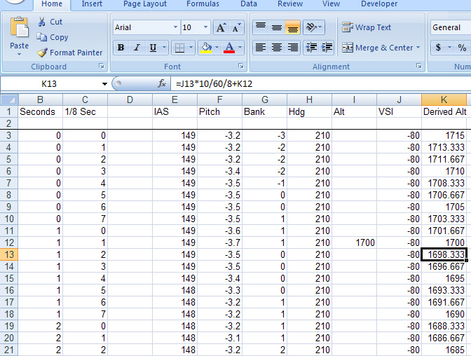Figure 4 - Manual Parameter Extraction

This FDR flightpath was played back in the Flight Simulator. When seen from the pilot’s perspective in the simulator (Figure 5), the playback closely matched the real HUD display. This helped to validate the process, and was an indication that the data was reasonable.
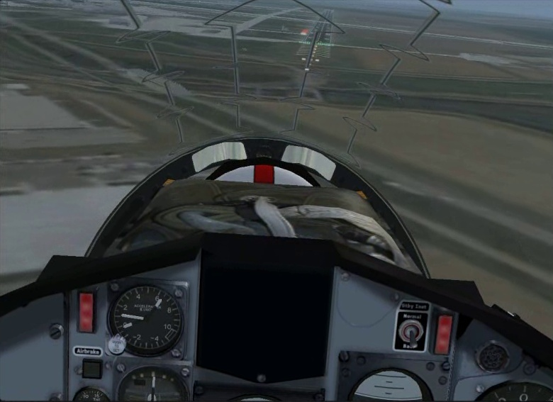Figure 5 - Initial Visualization
In order to model the movements of the lead aircraft, the visualization was frozen at several points, specifically when the video sequence started, upon ground touchdown, and at an intermediate point. Within the frozen visualization, a Hawk aircraft was moved left/right, forward/back, and up/down until its position and size in the visualization matched the lead aircraft seen in the corresponding frame of the HUD video. When the model and video matched, the lat, long and altitude of the model were noted. Next, a linear interpolation was made between the aircraft positions for the length of the video, resulting in an approximate FDR of the lead aircraft. Pitch, bank and heading from the second aircraft were re-used for the lead.
Upon visualization in the flight simulator (Figure 6), the pilot’s perspective closely matched that of the HUD video. The visualization was recorded from several camera perspectives in the simulator, including a top-down view, a chase plane view, a tower view, and from a virtual camera located at the touchdown point on the airfield. The footage was synchronized and mixed with the original HUD footage in Adobe AfterEffects. It became clear that analysis of a video could result in a 3D visualization that gave much more insight into the event than the original HUD video.
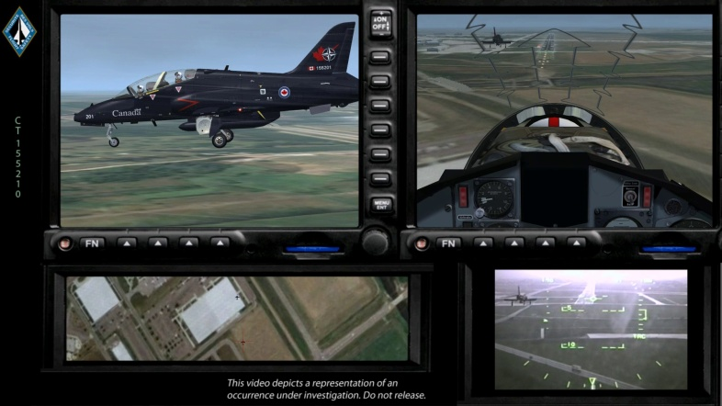Figure 6 - Final Visualization
Automated Data Extraction from HUD
In 2010, DFS obtained a copy of SynthEyes, software used for Special Effects in video and film productions. The HUD footage was revisited in order to determine if some of the video analysis processes could be automated. Tracker were placed at the -45, -30, -15, -5, 0, 5, 15, 30 and 45 degree bank indicators, and their x-y positions were exported from the software. Next, a moving tracker was placed on the tip of the triangular bank indicator (Figure 7), which resulted in a spreadsheet depicting the position of the triangular indicator for each frame of the video. Using a mathematical formula that took into account the curve of the bank scale, interpolated bank values were calculated for each frame of the video. This showed that the manual time-consuming frame-by-frame data extraction could be replaced by even more accurate video tracking and analysis.

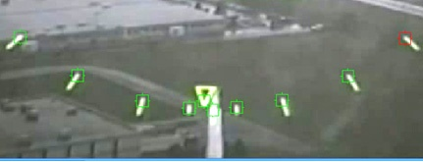Figure 7 - Tracking Angle of Bank
Trackers were also placed on the tail and flap/wing intersections of the lead aircraft (Figure 8), and the resulting x-y data was reviewed. In some portions of the video, the aircraft could not be completely discerned because of blooming, which caused the trackers to lose lock. By enhancing the contrast and gamma of the video, successful tracking of the aircraft components was achieved. A 3D Hawk model was imported into the software and matched to the aircraft in the video. Although the aircraft was not close enough to the camera to derive its distance and orientation throughout the sequence, there was some success which indicated that this methodology could be useful in deriving an aircraft’s position and orientation in space based solely on video.

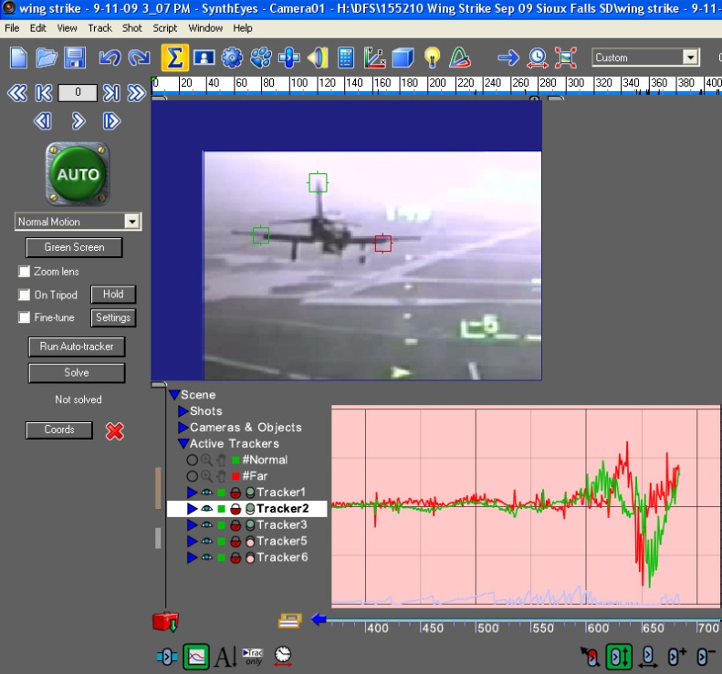Figure 8 - Automated Aircraft Tracking
CF188738 Hornet, Lethbridge AL

During an air show practice at Lethbridge County Airport, CF188738 experienced a loss of thrust from its right engine while conducting a high alpha pass at 300 ft above ground level. Unaware of the problem but feeling the aircraft sink, the pilot selected military power on both throttles to arrest descent. The aircraft continued to sink and the pilot selected maximum afterburner on both throttles. The aircraft immediately started to yaw right and continued to rapidly yaw/roll right despite compensating control column and rudder pedals inputs. With the aircraft at approximately 150 feet AGL and about 90 degrees of right bank, the pilot ejected from the aircraft. The aircraft continued to yaw/roll right with its nose descending in a tight right descending corkscrew prior to hitting the ground nose first. The ejection and seat man separation worked flawlessly, but the pilot landed firmly under a fully inflated parachute and was injured when he touched down.
The CF188 Hornet is not equipped with an FDR, and was not carrying an ACMI pod. Much of the recorded maintenance data was lost with the destruction of the aircraft. External video and photos of the subject flight were the only record of its flight path prior to the accident. Luckily, it was media day at the airport, and the crash was caught from several different angles. It was decided that the aircraft position thoughout the incident would be determined through triangulation.

Triangulation

Webster’s defines triangulation as “A trigonometric method of determining the position of a fixed point from the angles to it from two fixed points a known distance apart.” In our case we knew where the two videographers were located, and the bearing from each to the aircraft could be calculated by interpolating between know ground references.

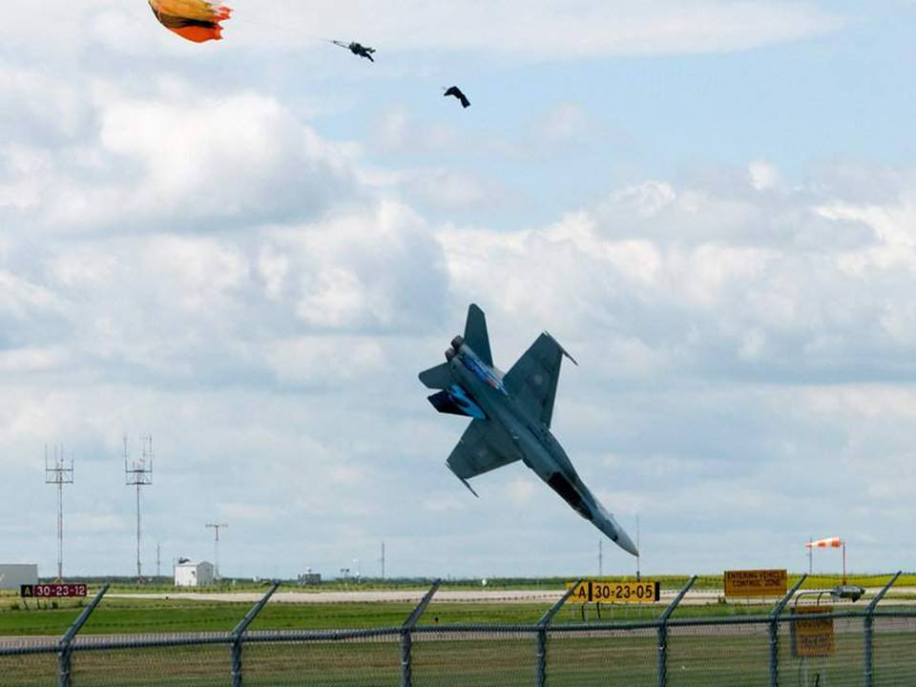Figure 9 - Witness Photo
The first step was to review Video #1 in Syntheyes, and track the centre of the aircraft. Major ground features, such as the TwoTrees, and the SmallBush were tracked throughout the whole video (Figure 10).
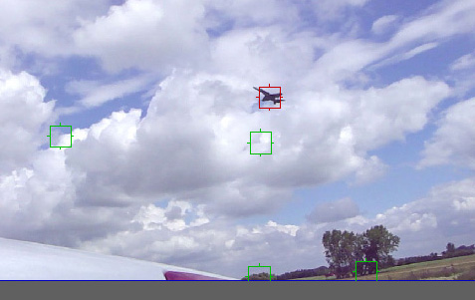Figure 10 - Tracking Features in Video #1
The camera positions, as well as the tracked major ground features were marked on a satellite image. The lat and long of each was determined, and from that, a bearing to each prominent ground feature was calculated using the course between points formula which was based on the spherical law of cosines. It should be noted that these bearings were quickly checked with the Google Earth angle/distance function, and several minor mistakes were found and corrected.
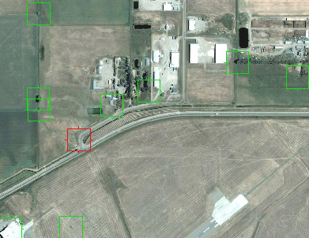Figure 11 - Selection of Ground Features
In order to calculate a bearing to the aircraft, its position had to be interpolated between two known bearings in each frame. Unfortunately, the video rarely showed two prominent ground features in the frame. As a result, prominent cloud features were chosen that could act as a bearing reference for the aircraft. As the clouds did not move significantly during the 30 second video, they could be used as a relatively stationary reference. These cloud features were also tracked within Syntheyes.
Sample video frames were stitched together in Photoshop to form a panorama covering all the ground and cloud references. Measurements of their relative positions were made in Syntheyes, and bearings for each cloud feature were calculated by interpolating their position between the known ground features. The bearing to the aircraft could then be calculated by interpolating between ground or cloud features.
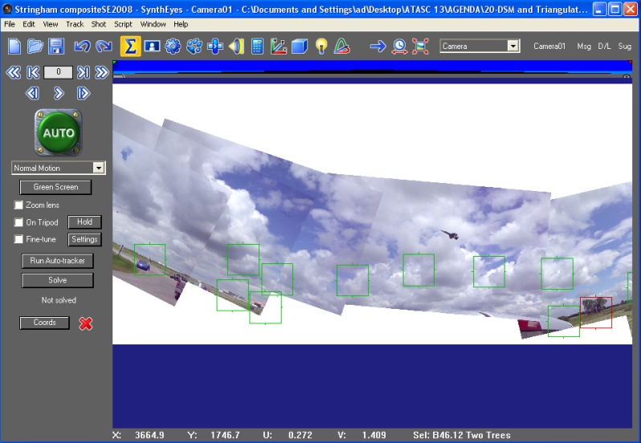Figure 12 - Selection of Features in First Panorama

Similarly, Video #2 was reviewed, and prominent ground and cloud features were tracked. The tracker position data was saved and imported into Excel.
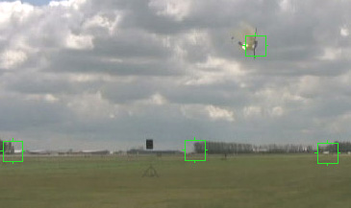Figure 13 - Tracking Features in Video #2
A panorama of the CF 188 Video #2 footage was also made. During the sequence, the camera was initially zoomed on to the aircraft, then zoomed out as the aircraft approached. As a result, when the stills were stitched together, they appear small on the left, but large on the right. This did not appear to significantly affect results.
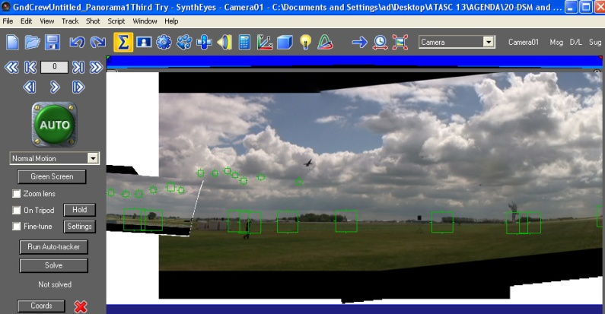Figure 14 - Selection of Features in Second Panorama
In order to calculate bearings to all the prominent cloud features, the positions of the ground features in the panorama still were plotted in excel against the calculated bearing of each ground feature. A second order polynomial trendline was fitted to the data, and the curve matched the data well. By substituting the position, x of each cloud feature into the resultant polynomial, a reasonable bearing of the cloud feature could be calculated.
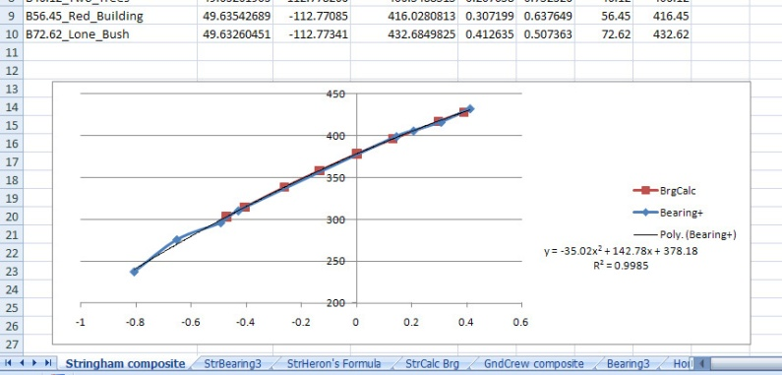Figure 15 - Plotting Position Against Bearing
The data was transferred into a spreadsheet that contained the horizontal and vertical position of the aircraft, the position of a ground/cloud reference to the left of the aircraft along with its associated bearing, and the position and bearing of a ground/cloud reference to the right of the aircraft for each frame of video. The proportional distance of the aircraft between the left and right references was calculated, and applied to the two associated bearings in order to derive an estimated bearing for the aircraft. The aircraft bearings were plotted against the frame number (Figure 16). A sinusoidal curve was fit to the data in order to smooth it. The deviations from the red curve near frame 1300 occurred when the camera was panned far above the horizon, and may be an indication that it was not held level during that period. Regardless, reasonable bearing data was derived from the camera. It indicated that the camera (Video #1), followed the aircraft to the left, then stopped and panned right near the end of the sequence. This can be verified in the footage.

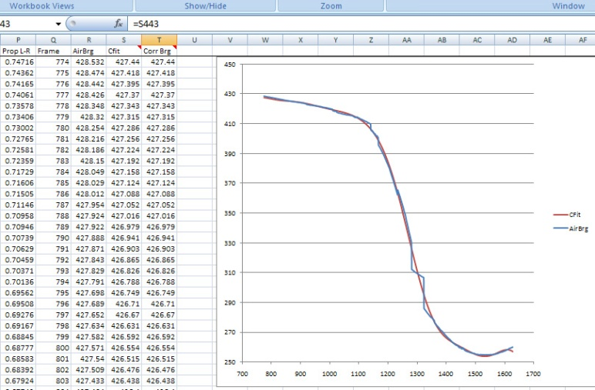Figure 16 - Plotting Bearings Against Time

For the Video #2 footage, the derived bearing data was even better (Figure 17). This is attributable to the fact that the camera was held level throughout the sequence. The graph showed that the camera steadily tracked the aircraft to the right, starting with a bearing of 77.3 degrees, until the end of the sequence. Again, this corresponds to what can be seen from the footage.

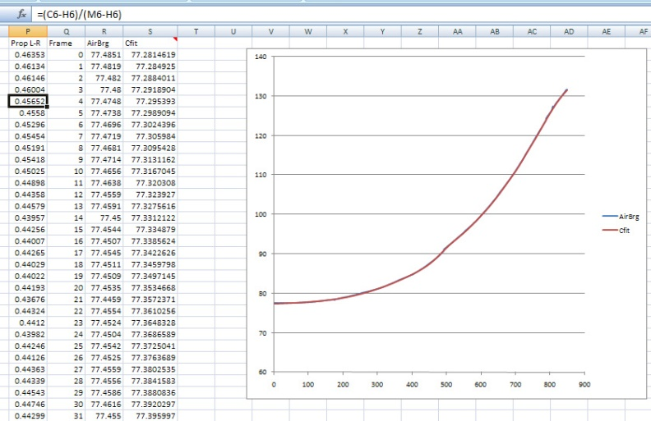Figure 17 - Plotting Bearing Against Time (Second Video)
The data from the two cameras was synchronized. At frame 1574 of Video #1, and frame 800 of Video #2, the pilot’s ejection seat is clearly firing. As both videos were recorded at 29.97 frames per second, the data from the two cameras were synchronized. Using the lat and long of the two camera positions, the lat and long of the aircraft was calculated at each frame, using the Intersecting Radials formula, again based on the spherical law of cosines (Figure 18). The blue track clearly shows a problem near the end of the flightpath. This is caused by ambiguity. When the cameras are pointing at each other, it is clear that the aircraft is between them both, but exactly where cannot be calculated by this means.
In order to address this ambiguity, an estimated path was produced, then the position along this path at each moment in time was derived. To get the path, the clearly ambiguous data was removed, and a forth order polynomial curve was fit to the remainder, resulting in a curve (shown in red) that matched the data without ambiguity. Next, a visual basic macro was produced that for each frame, extended a line from the Video #2 camera position to the polynomial curve at the calculated bearing to the aircraft. This gave a lat and long for the aircraft at each frame in the ambiguous range.
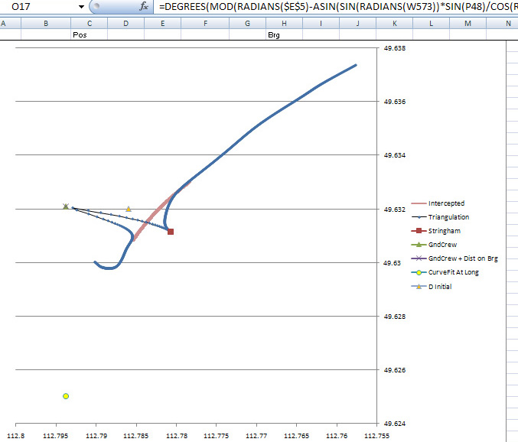Figure 18 - Plot of Lat/Long Position
The resulting flight path looked reasonable, and matched the southwest trajectory of the actual aircraft. For the simulation, the expected heading was calculated for each frame. This was done by calculating the track from each lat/long position to the next. The results were surprising. As shown in Figure 19, they revealed a bias starting at the 20 second mark, and a spike in the heading at the 27 second mark. The bias coincided with the end of the ambiguity zone previously calculated. As a result, a larger area of the ground track was removed and filled with the polynomial curve fit.
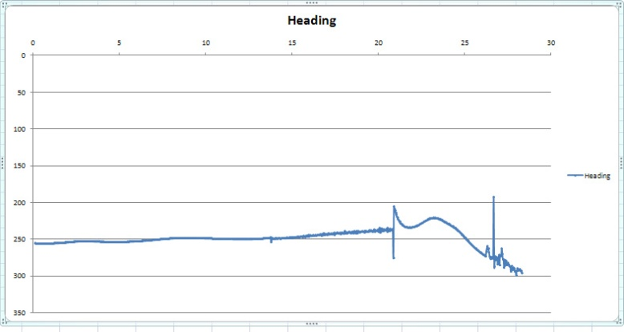Figure 19 - Plot of Heading Against Time
The spike in heading was found to coincide with frame 1574 of the Video #1 footage. At this frame, the tracker on the white sign clearly jumped from the centre to the right side of the sign (Figure 20). The tracker was moved back to the centre of the sign and the calculations were refreshed.
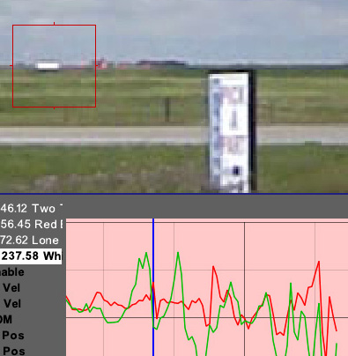Figure 20 - Faulty Tracker
The two corrections dramatically smoothed the estimated heading (Figure 21). This showed how the graphs could visually lead the analyst to errors, and improved the level of confidence in the process.
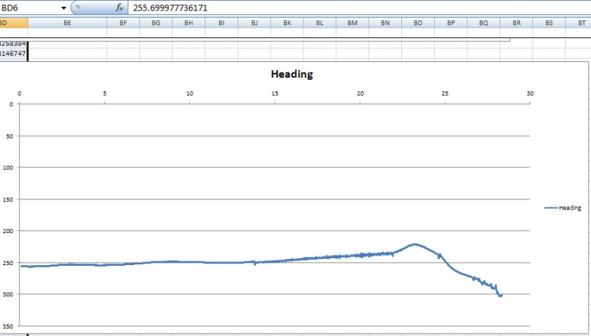Figure 21 - Corrected Heading Against Time
The data, including timestamp, lat/long, and heading were input into the flight simulator (Microsoft Flight Simulator X). A recording of the flight was made in a top-down view. In post-processing (Adobe AfterEffects), an orange line was drawn between the aircraft and the Video #1 camera, and a yellow line was drawn between the aircraft and the Video #2 camera position. The synchronized videos from each camera were also displayed in the corners, surrounded by a colour-coded frame. The track was reviewed many times to confirm that the position and orientation to the cameras seemed correct. The visualization revealed previously unknown information. The aircraft approached the runway with a curving left turn, rather than a straight-in approach as originally thought. This makes sense, as the aircraft had circled the airfield to the left.
Developing the triangulation workflow was difficult and initially took a long time, but subsequent projects can now be done within a period of days, using the workflows and spreadsheets. This process can also be applied to still photos, if they can be synchronized with the video.
The next step that will be conducted in the near future will be to calculate the aircraft height above ground based on the video. This can be done by determining the camera focal length, then comparing the distance of the aircraft from the camera to the height of the aircraft image above the horizon. Calculating the focal length will be difficult, but can be derived by comparing the measurements of a pick-up truck in the video to the actual measurements of the truck.

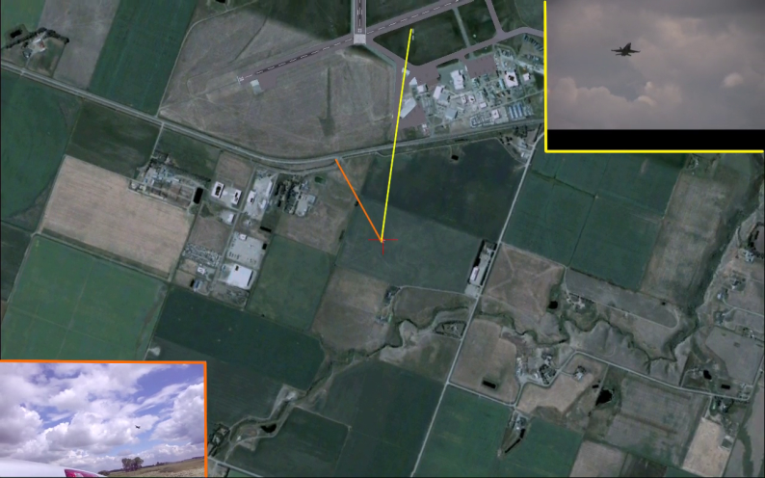Figure 22 - Final Composite Visualization
Matchmoving
Much more than the position and altitude can be derived from videos. Hollywood has long employed a technique called matchmoving in films, in order to realistically add digital effects to a hand-held camera shot. In this process, the individual pixels in the film/video are tracked and the pan, tilt, zoom, and movement of the camera relative to the scene is mathematically calculated. This matchmoving process was conducted on footage of the crash to derive the height, position, pitch, bank, and heading of the aircraft for the duration of the footage.
Before the motion of the aircraft can be calculated, the movement of the camera must be derived. This ensures that a shake of the camera is not interpreted as a vertical jump of the aircraft. As the aircraft is moving independently of the camera and background, an exclusion rectangle is drawn around it so that it does not influence the trackers which are trying to derive camera movement (Figure 23).
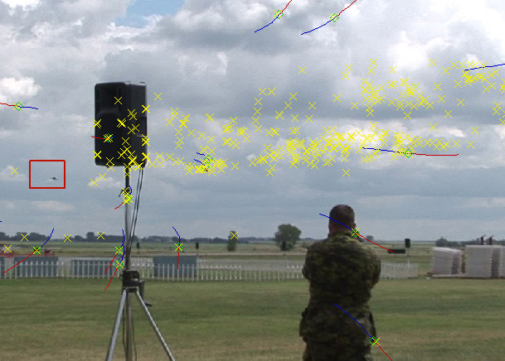Figure 23 - Tracking Camera Movement
Once camera analysis is complete, the software knows exactly how the camera moved during the video – vertically, horizontally, forward/back, pan, tilt, roll and zoom. With these parameters determined, analysis of the aircraft (object tracking) can begin.
This time, the scene is not tracked, but trackers are placed on the nose, tail, wingtips, exhausts, and other discernable points of the aircraft (Figure 24). A 3D model of the hornet is imported, and the aircraft trackers are matched to the corresponding nose, tail, wingtips, etc on the model. The software is instructed to adjust the position, height, pitch, roll and yaw of the model to match that of the aircraft in the video.
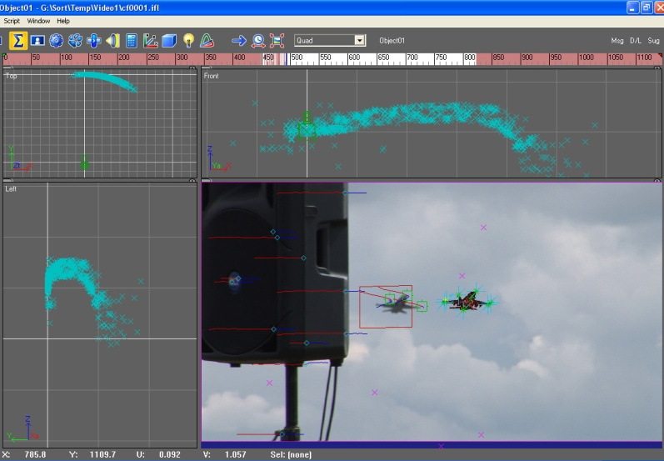Figure 24 - Tracking Aircraft
The software superimposes the wireframe model over the aircraft in the video so that the tracking and matchmoving can be visually validated (Figure 25). The resulting position, height and attitude calculated by the software can be employed as an FDR, and analyzed to calculate flight parameters such as groundspeed, heading, roll rate and other information.
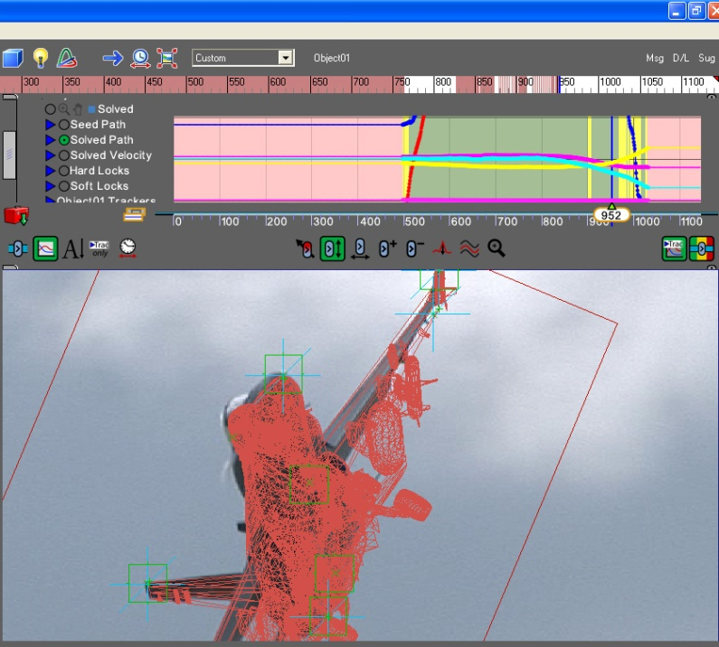Figure 25 - Matchmoving Model to Aircraft

Tracking and matchmoving are complementary. Tracking is useful for modeling the flight path when the aircraft is very small in the frame. At these types of distances, matchmoving software is unable to detect changes in attitude or distance of an aircraft. Matchmoving is useful when the aircraft fills the screen, and is relatively close to the camera. It can provide detailed attitude information that can be used in visualization or fused with other data, such as simulation.

Conclusion
There are ever-increasing sources of video which may capture a flight incident: cameras, smartphones, Ipods, as well as security and airport ground surveillance systems. Many aircraft have on-board systems that record HUD or cockpit imagery. Analysis of even a single video can produce massive amounts of data which could be useful in an investigation. Analysis of this video imagery can be used to validate FDR flight path data, and in its absence, can even replace it.
One video can provide a significant amount of information, but additional videos or photographs taken from a different location can reveal, by triangulation or other processes, more than could otherwise be found. This fusion of data from multiple sources can be further improved by combining it with data from an FDR, radar, or simulation to produce an optimal collaborative representation of the event.
Even a single video can reveal the final flight parameters of an aircraft through the process of matchmoving. This data can be played back in a simulator to visualize the event from any perspective, including the aircraft cockpit. Visualization can be critical in understanding why an accident took place, and to help others understand in order to prevent reoccurrence. Video analysis and visualization are capabilities that are complementary and have great potential to support investigation and improve flight safety.

References

Aviation Formulary by Ed Williams http://williams.best.vwh.net/avform.htm

