Analysis of Fuel Tank Explosion aboard Airplanes
By
N. Albert Moussa and Venkat Devarakonda
BlazeTech Corporation
29 B Montvale Ave., Woburn MA 01890
Phone: 781-759-0700 Fax: 781-759-0703 www.blazetech.com

Brief bio of presenter
Dr. Moussa has 40 years of experience in aircraft fire and explosion, a subject on which he teaches an annual four-day professional course. He has consulted for the FAA, Air Force, Navy, Army, NASA, DOT, Boeing, GE and Northrop. His credentials include: William Lockwood Memorial Lecture Award, Engineer of the Year by the NE Section of AIAA, AIAA Distinguished Lecturer, Best Papers by SAE and ASEI, and several ASME citations. He served on national committees and was Associate Editor of an ASME Journal. He authored one book and over 150 publications, reports and presentations, and investigated several major aircraft fire accidents. He has forewarned about aircraft fuel system vulnerabilities before the TWA 800 and Concorde disasters. He received a B.S. from Stanford University and M.S./Ph.D. from MIT, with both dissertations on fire.

Summary
The paper highlights analyses of aircraft fuel tank explosion performed over two decades that culminated in a model called BlazeTank. The model covers first, the aircraft conditions leading to flammable vapors inside a fuel tank including the effects of fuel properties, environmental conditions, altitude and flight profile. Second, the types of ignition sources and their requirements in terms of energy, temperature and size are reviewed. When data are not available, such as for hot surface ignition in the ullage, the model is used to predict the minimum ignition temperature as a function of hot spot size, filling in the knowledge gap. Third, the explosion overpressure is predicted as a function of time and fuel equivalence ratio and the predictions agree very well with measurements. Fourth, two different limiting oxygen concentration requirements for fuel tank inerting are discussed and the relevant data are presented. BlazeTank can aid in the evaluation of such different requirements and in accident investigation, where conditions are typically very complex and data are scarce.

Background
The aviation industry has suffered several Center Wing Tank (CWT) explosions. On May 11, 1990, the CWT on Philippine Airlines B737 exploded while the airplane was pushing back from gate in Manila resulting in 8 fatalities. On July 17, 1996, twelve minutes after takeoff from JFK airport, at 13,800 feet above MSL, an explosion occurred in the CWT of TWA 800. The B747 crashed over the Atlantic Ocean, resulting in 230 fatalities (everyone on-board). The NTSB conducted a detailed investigation of this accident, including testing and modeling, to determine what happened. On March 3, 2001, the CWT of Thai Airlines B737 exploded while the airplane was parked at gate in Bangkok undergoing preparation for flight (1 fatality and 6 injuries). In all three cases, the CWT was nearly empty, the outside air temperature was hot and the air packs were working hard to provide cooling. To protect against such accidents, the FAA issued several Airworthiness Directives, SFAR 88, and the requirement of a flammability reduction system on-board transport category airplanes.

BlazeTank
Since the late 1980’s, BlazeTech has been analyzing aircraft fuel tank explosion under a wide range of conditions (Moussa, 1990). This effort has culminated in a model called BlazeTank (Moussa 1998) that addresses the key questions typically posed in the above accidents, namely: Under what conditions is the ullage (void space above the liquid fuel in a tank) flammable? What are the requirements for an ignition to occur? What overpressure is produced and will it fail the tank? These questions are addressed as a function of fuel tank specifications, environmental conditions, flight profile and potential ignition sources inside the tank. The main input/output parameters of BlazeTank are shown in Figure 1 and will be discussed throughout the paper. The results have been used to forewarn about the vulnerability of aircraft fuel tanks such as TWA 800 and the concord disasters (Moussa 1997). This paper describes briefly the model capabilities and provides illustrative results. Whenever test data are available, they are compared with the model predictions to establish model validation. However, relevant data are limited but one can judge the reasonableness of the formulations in the model and the predicted trends.
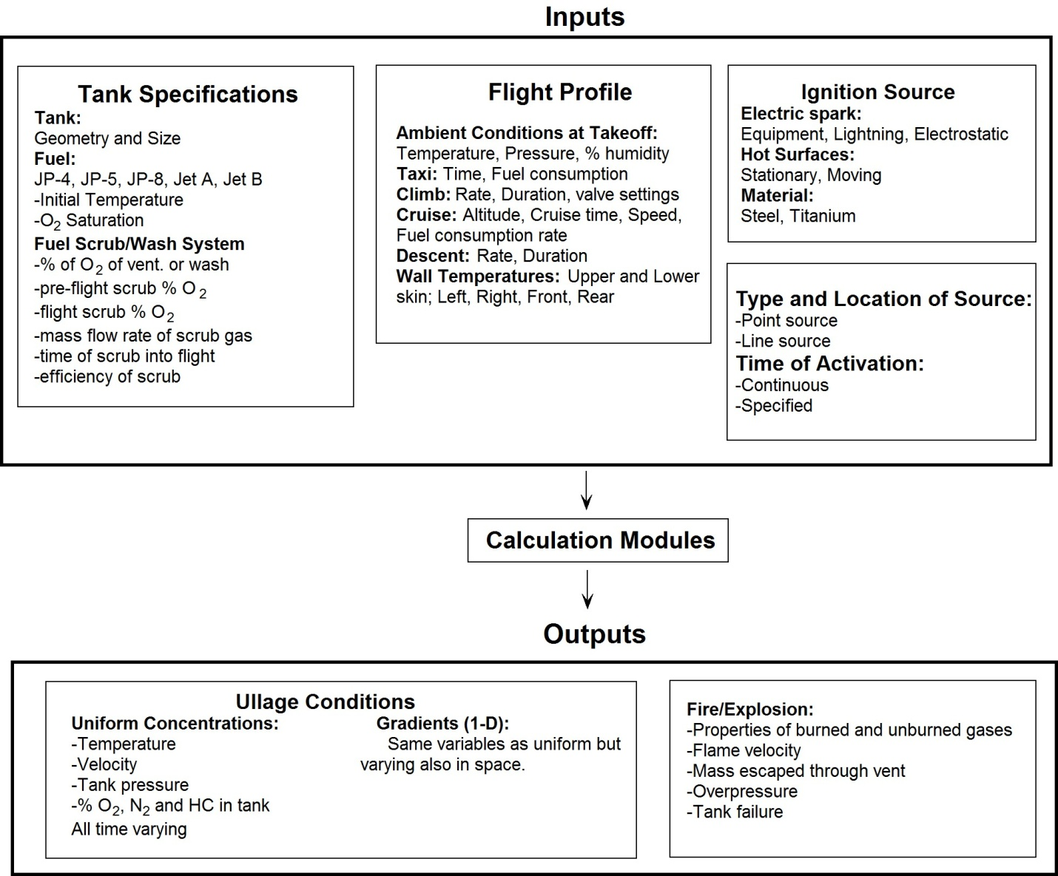
Figure 1: Main Inputs/Outputs of BlazeTank Model

Ullage Flammability
Representing the fuel tank as a box (see Figure 2), a heat and mass balance is performed on the liquid fuel and the ullage taking into account processes such as mass and thermal diffusion, evaporation, outgassing and dissolution, heating from the walls, and venting and inerting parameters. Thus, the temperature and composition in the ullage are calculated as a function of time for a given set of initial tank conditions and a flight profile.
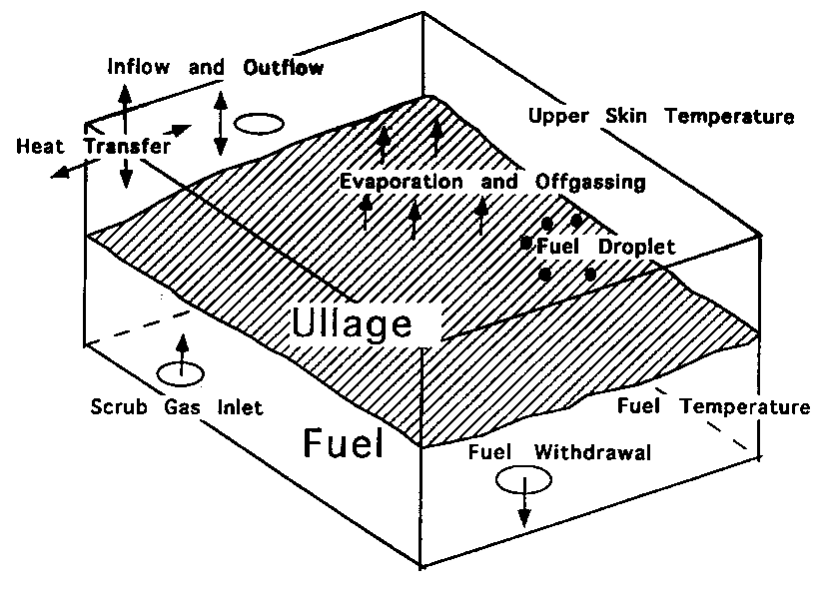

Figure 2 Schematic diagram of the fuel tank-- summary of various processes.

The model predictions of the effect of altitude on ullage flammability are illustrated qualitatively in Figure 3 for a simple case where the concentrations are assumed to be well mixed (uniform). At a given fuel temperature, the fuel vapor pressure (red bar) is constant regardless of altitude while the partial pressure of air (green bar) decreases with increasing altitude. Accordingly, the fuel vapor concentration in air increases with increasing altitude; and an ullage that is below the Lean Flammable Limit at MSL can become flammable at higher altitudes.
Figure 3 Fuel vapor pressure, air partial pressure and % fuel in air (volume) as a function of altitude
Repeating this calculation at various initial fuel temperatures and altitude yields the classical flammability envelops shown in Figure 4. The inverted U-shaped curve delineates the flammable region with the Lower and Upper Flammability Limits (LFL and UFL) on the left and right side, respectively. Figure 4 shows the results under static equilibrium conditions for Jet A and Jet B. Dynamic, non-equilibrium conditions such as the effects of gradients or slosh can be calculated by the model. For example, the gradient calculation can account for the higher fuel vapor concentration near the liquid surface and the higher oxygen concentration near the vent. This affects the amount of gases in the ullage that are flammable during a flight profile, which affects the likelihood of ignition and the resulting overpressure.
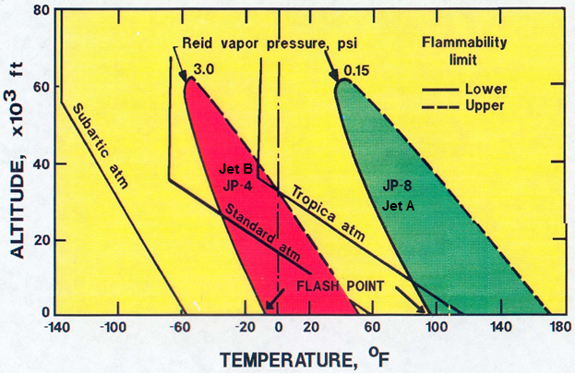
Figure 4 Equilibrium Flammability Envelops for various fuels and atmospheres

Ignition Sources
In the model, the potential ignition source can be located and activated anywhere and anytime in the tank as an input. The main types of ignition sources in a fuel tank are electrical sparks and hot surfaces. Electric sparks can be produced by electrostatic discharge, lightning strikes, frayed wires or shorts on fuel pumps and gages, and copper sulfate deposition on electrical contacts. The spark energy required to produce ignition depends on the fuel air composition, the temperature and pressure of the mixture and the presence of fuel mist (if any). It can be as small as 0.2 mJ. Accordingly, explosion proof equipment and electric bonding are employed throughout the tank to prevent ignition.
Hot surfaces can result from overheating of pumps. The temperature required for ignition depends on the catalytic effect (if any) and size of the hot surface, and the state (liquid or vapor) and temperature of the fuel, the local oxygen concentration and tank pressure. Measured minimum hot surface ignition temperatures are shown in Figure 5 for liquid fuels, hydraulic fluids and lubricating oil. Note the large variability in the results (by up to 400 F), presumably because of differences in test conditions.
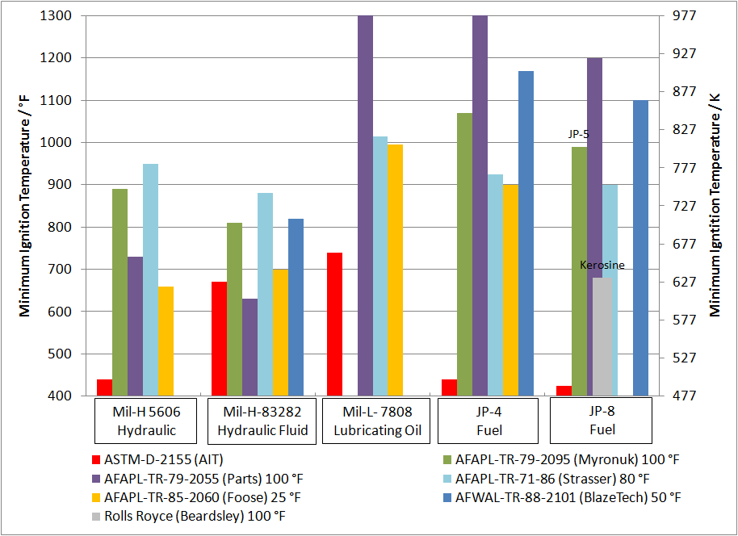
Figure 5 Minimum Temperature Measured for Hot Surface Ignition of Various Aircraft Liquids
Because similar data for hot surface ignition of fuel vapors are lacking, we used BlazeTank to calculate them. The model divides the ullage into two zones as shown schematically in Figure 6: 1) a natural convective boundary layer near the hot spot and 2) the remainder of the ullage assumed to be well mixed at a bulk temperature T_{b}. We assumed one dimensional heat transfer in the boundary layer because gradients in the direction perpendicular to the hot spot dominate over those in the other directions. During the initial stage of boundary layer development, the temperature in the bulk of the tank is undisturbed and remains at the initial value. With time the bulk temperature increases due to heat transfer from the boundary layer and in turn affects the “free stream” conditions of the boundary layer. Near the hot surface, chemical reactions between fuel and air initiate according to kinetics parameters derived from the fundamental ignition test data of Mullins et al. Ignition is assumed when the heat produced by chemical reactions is equal to the heat loss from the hot spot (according to the classical Van’t Hoff criterion.)
Figure 6: Schematic of key heat transfer processes occurring near a hot spot in the ullage.
Thus, the model calculates the boundary layer and heat release rate profiles near the hot spot as shown in Figure 6. The latter is much steeper than the former which is reasonable due to the strong non-linear dependence of chemical reaction on temperature. We found that the bulk temperature rises linearly with time and the rate of rise increases with increasing hot spot diameter, as expected. The rise in bulk temperature also increases the rate of chemical reaction but this effect is negligibly small because the bulk temperature was much lower than the Auto Ignition Temperature (AIT) of Jet A (~510 K).
The predicted hot surface ignition temperature as a function of surface size is shown in Figure 7 for a flammable Jet A vapor/air mixture and various pressures and heating durations (not reported in the figure for clarity). For reference, the only data point found in the literature on such Jet A vapor ignition is 1000 ºK for a 1”x3” (~0.04 spot size) horizontal hot surface (Summer). Also, the predicted trend of a decrease in ignition temperature with increase in hot surface size is reasonable – the larger size enables the chemical reaction to build up compensating for the lower temperature. This trend is also consistent with the classical measurements in the literature albeit for liquid hydrocarbons not vapors (Kutcha).
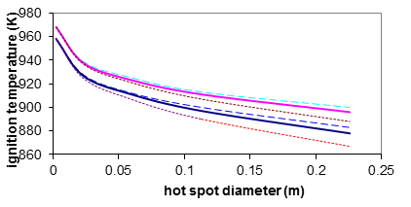
Figure 7 Predicted minimum hot surface ignition temperature as a function of hot spot diameter for Jet A vapor/air mixture under various pressures and heating durations

In the above calculation, the hot surface is stationary and at constant temperature. We analyze below a dynamic case where debris from an engine burst (such a turbine blade) penetrates and traverses the ullage space in the tank. This is illustrated in Figure 8 which shows the temperature time history of a film of gases near the blade (dashed curves). The temperature starts at the blade initial temperature (700 K for a Titanium blade and up to 1100 K for an Inconel blade) and decreases as a function of time due to blade cooling. The solid curve shows the temperature-time requirements for ignition of a flammable fuel vapor/air mixture based on kinetics considerations. The Titanium blade temperature never exceeds the requirements and therefore will not produce ignition, while the Inconel blades does. The horizontal curve indicates the time it takes for the blade to traverse the fuel tank. Clearly ignition has to occur within that time. These concurrent requirements are only satisfied (i.e., ignition will occur) in the shaded triangle. Repeating this calculation for a higher altitude results in a much smaller region where ignition is possible because the thinner air is harder to ignite (not withstanding that the ullage is more likely to be flammable as indicated in Figure 3).
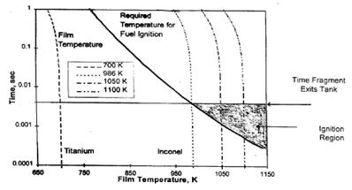
Figure 8 Conditions resulting in ignition by a turbine blade from an engine burst traversing the ullage

Explosion overpressure
Once ignition occurs, a flame will propagate consuming the flammable mixture (a process called deflagration). This is illustrated in the photograph of Figure 9 where a spherical flame has propagated outwardly from a central ignition point (an electric spark). Such flame propagation involves a number of complex coupled processes such as turbulence, diffusion, chemical reactions and heat transfer. It is represented in Figure 9 by a thin spherical flame sheet that divides the ullage into burned and unburned zones. Because of the confinement by the tank wall, the expanding burnt gases compress the unburned gases, thereby raising their temperature which in turn increases the flame speed. Since the pressure in the ullage equilibrates at the speed of sound that is orders of magnitude faster than the flame speed the pressure inside the tank can be assumed to be spatially uniform although increasing in time.
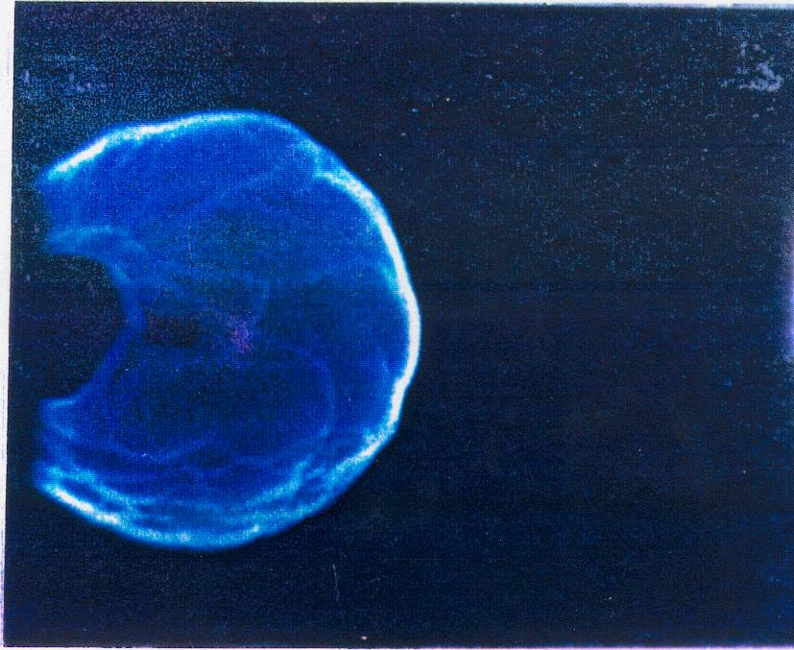
Figure 9 Photograph of flame propagation in flammable mixture

Figure 10: Model Representation of flame propagation in a flammable mixture
BlazeTank assumes that once the flame arrives at a location, combustion of the fuel vapors occurs instantaneously (this is reasonable because of the high flame temperature) according to a one-step overall reaction that converts fuel and air into carbon dioxide and water. By accounting for radiation heat loss from the flame to the tank walls and venting through ports (if any), the temperature of the burned gas and the tank pressure are calculated.
We compared the model predictions with the two test series that were performed after TWA 800 under NTSB sponsorships (Shepard et. al. 1997 and 2000). The tests simulated the actual conditions in the TWA 800 fuel tank at the time of the accident and are summarized in Table 1. The quarter scale tests were conducted in a trapezoidal tank resembling the CWT in Boeing 747 but as a single compartment while the HYJET tests used a cylindrical tank.
The tests measured mainly the explosion overpressure time history after ignition for various equivalence ratios (phi) as shown in Figure 11 and Figure 12 for the two test series, respectively. The key features of the pressure time history are: the pressure rises at an increasing rate until it reaches a peak when combustion is complete, after which it drops slowly due to heat loss from the hot gases to the tank walls; also the rate of pressure rise and the peak pressure increase as the mixture contains more fuel vapors (higher phi.) Figure 11 and Figure 12 also show the overpressures predicted by BlazeTank which are in excellent agreement with all of the above features of the measurements, thus validating our model. (The agreement for phi=0.99 in Figure 12 is not as good as the others because the test used El Monte Jet A while the model used the properties of LAX Jet A because we did not have the properties of the former.)
Table 1 Comparison of test conditions in two sets series simulating the TWA 800 fuel tank explosion

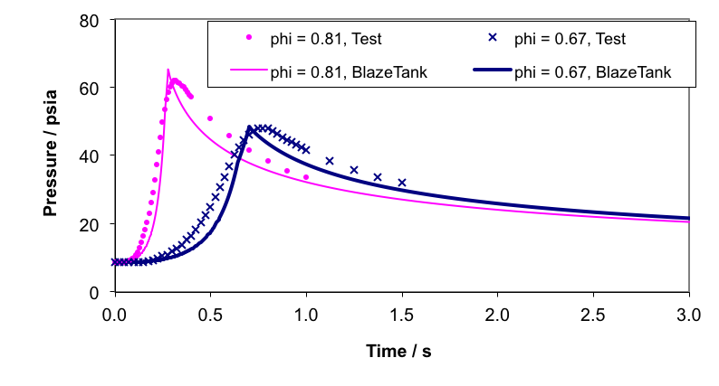
Figure 11: Comparison of BlazeTank predictions with measurements from quarter scale tests.

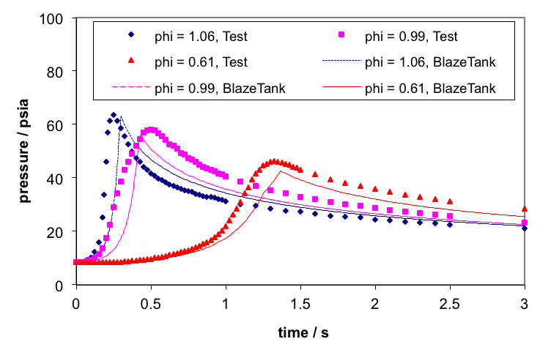
Figure 12: Comparison of BlazeTank predictions with data from HYJET facility tests.

Clearly the overpressures presented above are high enough to fail an airplane fuel tank. In addition, BlazeTank predicts the burn velocity, temperature and density of both the burned and unburned gases as functions of time. Typical results are shown in Figure 13 over the duration of the burn for the quarter scale set up and 2 equivalence ratios. (The results are very similar for the HYJET test series.) The temperature of the unburnt gases increases with time as they are compressed by the burnt gases. The burning velocity also increases with time because the unburnt gases are hotter. The increase in burning velocity is responsible for the aforementioned steepening of the pressure curves with time. Again, the time scales are shorter for the mixture containing more fuel vapors (higher equivalence ratio).
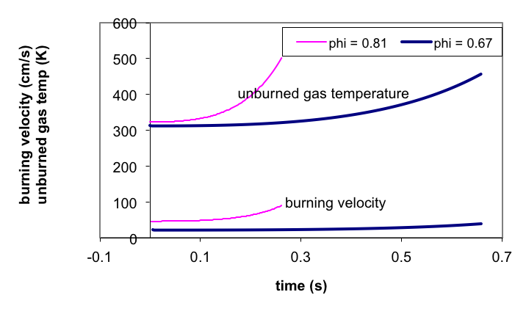
Figure 13: Unburned gas temperature and burning velocity as functions of time in quarter scale tests.

Fuel Tank Protection
It is well known that as the oxygen concentration is decreased, the heat release rate and the flame temperature are decreased, and below a Limiting Oxygen Concentration (LOC) the fire goes out. Early work by the Bureau of Mines and the military concluded that the LOC for jet fuels in an aircraft tank is 9% (Zinn). Recent FAA tests concluded that a less stringent LOC of 12 % is sufficient (Summer). In 2005, the FAA issued a ruling requiring a Flammability Reduction System (FRS) onboard transport category airplanes to ensure that the LOC does not exceed 12%. Typically, the FRS consists of an air separation module that produces a nitrogen-enriched air that is pumped into the fuel tank.
To shed light on this difference in LOC requirements, we reviewed the data available on this subject for Jet A and JP-4, including old and recent data as illustrated in Figure 14 and Figure 15, respectively (Moussa 2010). While our interest is in Jet A, there are more data available for JP-4 from which one can infer trends that are expected to apply also to Jet A. These figures were obtained by testing at different oxygen and fuel concentrations under a wide range of conditions including altitude, static vs. slosh, and with and without a fan to mix the ullage gases. The figures show an inverted U shaped curve that delineates the minimum LOC required for ignition at each fuel concentrations. As the fuel decreases (increases) towards the lean (rich) limit, the LOC increases significantly. The trough in the U-shaped curve is the lowest LOC that should be maintained to prevent ignition. Note that the LOC at the trough depends on the test conditions. Detailed examination of the data for both fuels suggests the uncertainties in any set of data are +/- 0.5%, and more importantly that the selected test conditions can lower the minimum LOC as follows:
- By 1% when a stronger ignition source is used although this effect is inconsistent amongst investigators.
- 0.5% to 1.5% when the ullage temperature is higher than ambient.
- up to 2% when dynamic effects are present (such as vibration, slosh and misting of fuel)
- 0.5% for the measured concentration gradients
These effects are fairly complex individually and even more so when combined. They can only be sorted out by systematic testing on Jet A (as was done in the past for JP-4) or by parametric calculations using a model like BlazeTank that accounts for the processes governing the LOC.
Figure 14 Limiting Oxygen Concentration for JP-8/Jet A (data from various sources)

Figure 15 Limiting Oxygen Concentration for JP-4 (data from various sources)

Closure
BlazeTank incorporates a large knowledge base that has been accumulated over many years. Its predictions have been in very good agreement with data when available for comparison. Otherwise, its predicted trends have been very reasonable. As such, it can be used to evaluate situations where data is generally not available such as new methods of fuel tank protection and the extremely complicated conditions of accidents.

References
- Disimile, P., et. al., “Limiting Oxygen Concentration (LOC) for Dynamic Fuel Tank Applications, Aircraft Survivability, Spring 2008.
- Kuchta, J.M., Bartkowiak A., and Zabetakis M.G., “Hot Surface Ignition Temperatures of Hydrocarbon Fuel Vapor-Air Mixtures,” J. of Chemical Engineering, Vol. 10, No. 3, July 1965, pp. 282-288.
- Moussa, N. Albert, "Flammability of Aircraft Fluids", presented at the Society of Automotive Engineering AEROTECH'90 Conference in Long Beach, CA., October 1-4, 1990 SAE Technical Paper 901949.
- Moussa, N. Albert, et al, "The Potential of Fuel Tank Fire and Hydrodynamic Ram from Uncontained Aircraft Engine Debris,” DOT/FAA/AR-96-95, January 1997.
- Moussa, N. Albert, et al, “BlazeTank Model for the Flammability, Ignition and Overpressure in an Aircraft Fuel Tank,” with other, presented at the FAA’s International Conference on Aircraft Fire and Cabin Safety Research held in Atlantic City, NJ., Nov. 1998.
- Moussa, N. Albert and Venkat Devarakonda, “Factors Affecting the Limiting Oxygen Concentration Required for Ignition in an Aircraft Fuel Tank”, Presented at 6th Triennial International Aircraft Fire & Cabin Safety Research Conf., Atlantic City, NJ, October 25-28, 2010 .
- Mullins, B.P., “Studies on the Spontaneous Ignition of Fuels Injected into a Hot Air Stream II – Effect of Physical Factors upon the Ignition Delay of Kerosene-Air Mixtures,” Fuel, London, 23, pp. 234-252, 1953.
- Ott, E. and Lillie, R., “Influence of Fuel Slosh Upon the Effectiveness of Nitrogen Inerting for Aircraft Fuel Tanks”, AFAPL-TR-70-82, 1971.
- Roth, A. J., Johnson, A.M. and N.A. Moussa, “Hot Surface Ignition Tests of Aircraft Fluids”, with, AFWAL-TR-88-2101.
- Shepherd, J. E. et al, “Jet A Explosion Experiments: Laboratory Testing” Explosion Dynamics Laboratory Report FM97-5, November 1997.
- Shepherd, J. E. et al, “Results of 1/4-scale experiments, vapor simulant and liquid Jet A tests” Explosion Dynamics Laboratory Report FM 98-6, January 2000.
- Starkman, E. S., Stewart, P. B., Gott, R. E., and Lichtman, L., “Flammability of AN-F-58 (JP-4) Vapor with Nitrogen Inerting”, Fuel Ignition Studies Technical Report No. 1, Submitted to Air Material Command United States Air Force, Contract No. AF 33(600)-17677, November 1953.
- Stewart, P. B. and Starkman, E. S. , "Inerting Conditions for Aircraft Fuel Tanks, " WADC Technical Report No.55-418, 1955.
- Summer, S., “Limiting Oxygen Concentration Required to Inert Jet Fuel Vapors Existing at Reduced Fuel Tank Pressures”, DOT/FAA/AR-04/8, 2004.
- Zabetakis, M. G. , "Flammability Characteristics of Combustible Gases and Vapors, " U. S. Bureau of Mines Bulletin 627, 1965.
- Zinn Jr., S.V., “Inerted Fuel Tank Oxygen Concentration Requirements,” FAA-RD-71-42, August 1971.

