Regulatory Runway Incursion Awareness Systems
Robert E. Joslin (MO3889)
Robert Joslin is the Chief Scientific & Technical Advisor for Flight Deck Technology at the Federal Aviation Administration. Previously Mr. Joslin was a Colonel in the United States Marine Corps and an FAA Flight Test Pilot with 37 years of military and civilian aviation experience in all types of military and civil jet, propeller, rotorcraft, and powered lift aircraft, involved in the certification of some of the latest technologies. He has extensive accident investigation experience and was accepted as a full member of ISASI in 1995.

Executive Summary
This study analyzed the effectiveness of current safety controls for reducing runway incursions, considered precedents from regulation-based technological controls, and explored runway incursion awareness systems as aircraft flight deck equipage. Reduction of runway incursions has been a top strategic objective for the Federal Aviation Administration (FAA) over the last decade^{1,2} and was most recently identified as one of aviation’s most critical continuing challenges in the 2010 FAA NextGen Implementation Plan³, the 2010-2011 National Transportation Safety Board (NTSB) Most Wanted List of Transportation Safety Improvements⁴ and the 2009 European Aviation Safety Agency (EASA) Annual Safety Review.⁵ Historical data indicate that the hierarchy of risk controls implemented to reduce runway incursion hazards have not achieved significant reductions, and now demands a regulation based technological solution through flight deck equipage of runway incursion awareness systems (RIAS).

Background

In October 2007 the FAA adopted the International Civil Aviation Organization (ICAO) definition of runway incursion as any occurrence at an aerodrome involving the incorrect presence of an aircraft, vehicle or person on the protected area of a surface designated for the landing and take-off of aircraft.^{6,7} The revised definition expanded the legacy FAA definition to include surface incidents and wrong runway departures, and changed some of the descriptors for the categories and types of runway incursions (Figure 1).^{8,9}

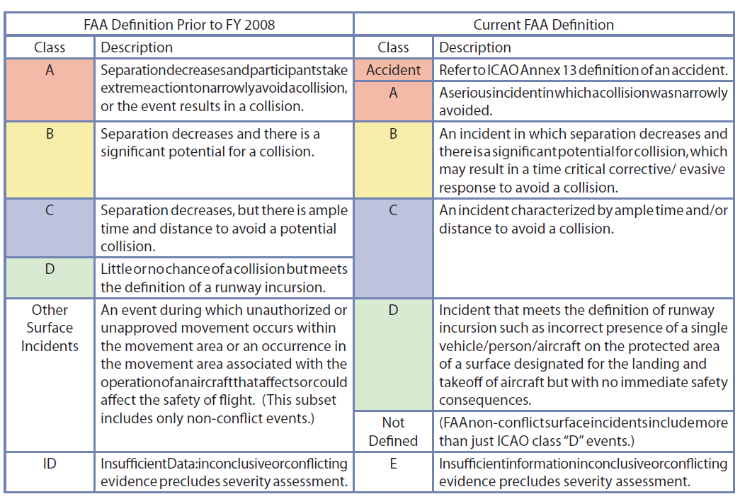
Figure 1. Previous and Current FAA Definition of Runway Incursion Severity Classifications adapted from the FAA National Runway Safety Plan 2009-2011

Runway incursions are also defined by type; operational errors/deviations (OE/D), vehicle-pedestrian deviation (VP/D), or pilot deviation [PD].^{10,11} The metrics selected by the FAA to examine national trends have been number, rate, severity, and type of runway incursion.¹² The FAA statistically combines Category A and B runway incursions together as serious runway incursions and most recently reported on the FY2011 1st Quarter Performance Report (http://www.faa.gov/about/plan_reports/Performance/quarter_scorecard) a 50% decrease in serious runway incursions compared to the 1st Quarter FY 2010. However the distinction between runway incursion Categories is somewhat subjective. A Runway Incursion Severity Classification (RISC) computer program was developed by the FAA and VOLPE National Transportation System Center with the aim of standardizing assessments of runway incursion events among the FAA and ICAO member states (http://www.icao.int/fsix/risc.cfm) as published in Appendix H of the ICAO Manual on the Prevention of Runway Incursions. The factors considered are proximity of the aircraft and/or vehicle, geometry of the encounter, evasive or corrective action, available reaction time, environmental conditions, and factors that affect system performance such as communication failures/errors.

Examples: A pilot deviation type runway incursion incident in Daytona Beach International Airport resulted in a horizontal clearance of 70 feet between an aircraft on its take-off roll and another aircraft that had inadvertently taxied onto the runway. Another pilot deviation runway incursion at Seattle-Tacoma International Airport resulted in a vertical separation of 400 feet, and zero horizontal clearance, between an aircraft that had just lifted off and directly overflew another aircraft that had inadvertently taxied onto the runway.

The former was recorded as a Category A serious runway incursion and the latter a Category C, however either one could have resulted in an accident. Collision avoidance was entirely by chance and temporal separation since there was no air traffic controller intervention or warning and no awareness or evasive action by the pilots. Hence for this study any Category of runway incursion was considered an equally weighted leading indicator, or precursor, to a more serious incident or accident. Gains or losses in individual Categories were dismissed, and only the aggregate number of annual runway incursions and the runway incursion rate were considered for trend analysis. Surface incidents for which there was insufficient data (Category E) were not considered.

Federal Aviation Administration

FAA runway incursion data for Fiscal Year (FY) 2000 through FY 2010 indicated that there has not been a significant decrease in the number of runway incursions (Figure 2). The expanded definition of runway incursion, that added surface incidents and wrong runway departures, was manifested by the spike in the number of recorded runway incursions commencing in FY 2008. After adjusting FY 2005-FY 2007 data to include the expanded definition of runway incursion, the data still indicated 24% more runway incursions in FY 2010 as compared to FY 2005(Figure 2). The most prevalent type of runway incursion was pilot deviations (PD), defined by the Flight Standards Information Management System (FSMIS)¹³ as actions of a pilot that resulted in a failure to comply with Air Traffic Control (ATC) clearance and/or instructions (Table 1). Pilot deviation type runway incursions comprised 65% of all runway incursions in FY 2010.

The FAA 2009-2013 strategic plan contained a FY 2013 performance target of reducing total runway incursions by 10% from the FY 2008 baseline of 1009 runway incursions.¹⁴ Intermediate fiscal year runway incursion reduction targets were 1% by 2009, 3% by 2010, 5% by 2011, and 7% by 2012. The 951 total runway incursions reported in FY 2009 met the performance target of a 1% reduction, that corresponded to not more than 999 runway incursions. The 966 total runway incursions reported in FY 2010 met the performance target of 3% reduction, corresponding to not more than 979 runway incursions. However the overall total number of runway incursions and the number of runway incursions classified as pilot deviations increased from FY 2009 to FY 2010 (Table 1). Data for the the 1st half of FY 2011 show an increase from FY 2010 for all types of runway incursions (Table 2).

In FY 2008 the definition of Runway Incursion was expanded
Figure 2. Runway Incursions FY 2000-FY 2010 adapted from http://www.faa.gov/ airports/runway_safety/ statistics. FY 2005-2007 data adjusted with new ICAO definition.

Table 1
Runway Incursion Totals and by Type for FY2000-FY2010 adapted from http://www.faa.gov/ airports/runway_safety/ statistics

Fiscal Year | Type OE/D | Type PD | Type VP/D | Total(Target)
2000 | 83 | 247 | 75 | 405
2001 | 91 | 232 | 83 | 406
2002 | 75 | 191 | 73 | 339
2003 | 89 | 174 | 60 | 323
2004 | 97 | 173 | 56 | 326
2005 | 105 | 169 | 53 | 327
2006 | 89 | 190 | 51 | 330
2007 | 105 | 209 | 56 | 370
2008* | 164 | 637 | 208 | 1009(Baseline)
2009* | 153 | 599 | 199 | 951(999)
2010* | 156 | 630 | 180 | 966(979)
*FAA expanded definition of runway incursions

Table 2
Comparison of Runway Incursion Totals and by Type for 1st Half FY2010-FY2011 adapted from http://www.faa.gov/ airports/runway_safety/ statistics

1st Half  Fiscal Year | Type OE/D | Type PD | Type VP/D | Total
2010 | 57 | 276 | 79 | 412
2011 | 87 | 289 | 86 | 462

Although the rate of Category A and B runway incursions met the FY 2010 FAA performance target of not more than .45 per million operations, the overall rate of runway incursions per million operations has steadily increased over the last six years from 12.3 to 18.9 (Figure 3).

Figure 3. Rate of Runway Incursions for FY2005-FY2010 adapted from http://www/faa.gov/ airports/ runway_safety /. FY 2005-2007 data adjusted with new ICAO definition.

European Aviation Safety Agency

The 2009 European Aviation Safety Agency Annual Safety Review¹⁵ listed runway incursions in the top ten accident categories and implemented a European Action Plan for the Prevention of Runway Incursions.¹⁶ Although runway incursion rate information was not provided, the Eurcontrol website (http://www.eurocontrol.int/runwaysafety) stated that the total number of runway incursions had increased every year since data collection began in 1999 and that presently there is an average of two runway incursion incidents each day in Europe, with 51% due to pilot deviations (Figure 4). The initial steep escalation in reported runway incursions was attributed to increased awareness and reporting during the initial development of the EUROCONTROL runway incursion tracking system. However the data gathered over the last five years has been through a mature reporting system with widespread awareness and show a continued rise in runway incursions.

Figure 4. EUROCONTROL Runway Incursions 1999-2008. Adapted from http://www.eurocontrol.int/runwaysafety/

Precedents
The FAA Notices of Proposed Rule Making (NPRM) for Traffic Alert and Collision Avoidance Systems (TCAS) and Terrain Awareness and Warning System (TAWS) provided insight of the path followed for past safety issues that demanded regulatory enforcement of hazard controls through installation of appropriate aircraft flight deck equipage. Accidents and incidents involving near mid-air collisions (NMAC) and controlled-flight-into-terrain (CFIT) reached unacceptable levels and continued to escalate until regulatory requirements were codified for aircraft certification and operation, through technological controls.^{17,18,19}

Near Mid-Air Collisions

Research and development of collision avoidance systems began in 1955 when it was determined that “see and avoid” and reliance on air traffic control for aircraft separation was insufficient. Traffic Alert and Collision Avoidance Systems did not reach sufficient technical maturity and operational effectiveness until 1987 when the regulatory requirement for installation of an appropriate FAA approved TCAS was first implemented for commercial air carriers, selected air taxi/commuter operations, and on airplanes used by foreign carriers flying in the U.S. airspace.^{20,21} TCAS combined a situational awareness display in the cockpit with distinct visual and aural alerts, linked to cockpit procedures to maneuver the aircraft away from the conflicting hazardous traffic. TCAS technology, as a regulatory-based control reduced NMAC by over 50% within 5 years (Figure 5). The regulatory requirement was subsequently extended to include cargo carriers and other types of flight operations.

1987-FAA requires TCAS

Figure 5. Near Mid-Air Collisions 1980-2008. Adapted from Research and Innovative
FAA Regulatory Requirement for TCAS in 1987
Technology Administration [RITA] Table 2-15: Number of Pilot-Reported Near Midair Collisions (NMAC) by Degree of Hazard²²

Controlled Flight Into Terrain

The genesis and path of regulatory-based Terrain Awareness Warning Systems (TAWS), also called Ground Proximity Warning Systems (GPWS) , was similar to that of TCAS. In the 1970’s there were an escalating number of accidents involving properly function airplanes, under the control of fully qualified crews, flying into terrain, water, or obstacles. National Transportation Safety Board (NTSB) studies, investigations and recommendations indicated that many of these accidents could have been avoided if a warning device had been installed.²³ The NTSB also concluded that the crew training and procedures in place were inadequate controls for CFIT.^{24,25} In 1974 a regulation-based technological solution for mandatory installation of ground proximity warning systems (GPWS) was implemented, initially for those operating large turbojet and turbine powered airplanes.^{26,27,28} GPWS combined a situational awareness display in the cockpit with distinct visual and aural alerts, linked to cockpit procedures to maneuver the aircraft away from the hazardous terrain or obstacle. Following the mandatory requirement for GPWS installations, the number of CFIT incidents dropped at a rate comparable to the reductions achieved in NMAC after the TCAS requirement was codified (Figure 6).

1974-FAA requires GPWS
Figure 6. Worldwide Controlled Flight Into Terrain accidents for transport aircraft. Adapted from Breen, B. C. (1999, January). Controlled flight into terrain. IEEE AES Systems Magazine, 19-24.²⁹

Call to Action
Every FAA strategic plan since FY 2004 has had reducing the risk of runway incursions as one of the organization’s objectives. yet runway incursions increased.^{30,31} The negative trend culminated with the 2006 Lexington Kentucky wrong runway take-off accident of Comair Flight 5191 that claimed 49 lives.³² Following the tragic Flight 5191 accident, the FAA launched a “Call to Action for Runway Safety”.³³ The “Call to Action” risk management plan for managing and reducing the risk, and controlling runway incursion hazards, encompassed a hierarchy of controls; designing the hazard out, physical guards or barriers, warning, advisories, or signals and procedural changes.^{34,35} ICAO grouped these controls, or aviation system defenses, under the three general categories of technology, training, and regulations and considered the “hard mitigation” of technology as the most effective.³⁶
Airlines, pilots, controllers, dispatchers, chief pilots and company executives were brought together in a series of face-to-face meetings in an effort to improve hazard controls for runway incursions. The FAA and industry leaders identified short-term steps to improve runway safety. These initiatives focused on improved procedures, increased training for airport and airline personnel, and enhanced airport signs and markings. Another short-term initiative was an agreement with the National Air Traffic Controllers Association (NATCA) for a voluntary reporting system. Mid-term and long-term goals were pursued to address maximizing situational awareness, minimizing pilot distractions, and eliminating runway incursions using procedures and technologies. The FAA completed an analysis of taxi clearances and found that more explicit instructions were needed from controllers to pilots. As corrective action, new requirements for precise routes to travel from the gate to the runway were instituted. The FAA also issued new requirements for aircraft to have crossed all intervening runways prior to receiving a take-off clearance. Other outreach efforts included the distribution of booklets, brochures and DVDs for pilots, which highlighted communication procedures for safe surface operations at towered and non-towered airports, online courses that educated pilots on runway safety, and safety seminars that encouraged safe practices on the airfield. The role of Flight Service Station (FSS) specialists was expanded to provide runway safety information to pilots using towered and non-towered airports and FAA Aviation Safety Inspectors (ASI) verified that pilots had current surface movement charts (airport diagrams) available. The FAA “Call to Action” also embraced initiatives for technology implementation in the airport environment, control tower, and cockpit designed to support operators in their compliance to procedures and recognition of potential hazards in the runway environment. Airports across the country installed runway safety-enhancing technologies such as Airport Surface Detection Equipment, Model X (ASDE-X), Runway Status Lights (RWSL), Final Approach Runway Occupancy Signal (FAROS), and Low-cost ground surveillance systems. The preponderance of the technological initiatives have been focused on air traffic controller awareness and not the flightdeck, where the most prevalent type of runway incursion of pilot deviations occurred. The one in-cockpit aircraft equipage initiative that focused directly on the reduction of pilot deviation type runway incursions was facilitating the certification and operational approval of Electronic Flight Bags (EFB) with Airport Moving Map Displays (AMMD) and an “ownship” symbol, but did not include other traffic or alerts. The EFB /AMMD equipage has been installed as voluntary non-essential miscellaneous equipment, not required by regulation.^{37,38} In 2007 the Airline Pilots Association International issued there own “Call for Action” in a white paper on Runway Incursions which echoed the FAA “Call to Action” and U.S. Commercial Aviation Safety Team (CAST) recommendations, but fell short of directly endorsing regulatory action for mandatory flight deck equipage of runway incursion awareness systems.³⁹

Flight Deck Technology

A critical NTSB finding from Comair Flight 5191, that has yet to be formally implemented, stated the following:

“the implementation of cockpit moving map displays or cockpit runway alerting systems on air carrier aircraft would enhance flight safety by providing pilots with improved positional awareness during surface navigation”⁴⁰

The NTSB recommendation was mirrored in the ICAO Manual on the Prevention of Runway Incursions which also recommended that regulators focus on runway incursion risk reduction in their oversight activities, with the objective of identifying potential new technologies to reduce the possibility of a runway incursion.⁴¹

In partial response to the NTSB findings from Flight 5191, the FAA initiated a demonstration program (Capstone 3) to examine how EFB and AMMD technology improved cockpit situational awareness to enhance surface safety.⁴² EFBs are an FAA certified electronic display system that provide pilots with aviation information. One EFB application replaces primary paper flight charts with computerized flight charts. EFBs are either stand-alone laptop-like devices (Class 1), portable but connected to an aircraft mounting device and using electrical power and data directly from the aircraft systems (Class 2), or fully integrated installed cockpit equipment (Class 3).⁴³ Many of the certified EFB systems incorporate AMMD technology, which use Global Positioning Systems (GPS) to show actual position (ownship) on the airport surface. AMMD technology allows pilots to see exactly where their aircraft is on the airfield in real time, reducing the chances of losing situational awareness and being in the wrong place. The FAA Office of Runway Safety awarded contracts to several air carriers to equip portions of their fleets with EFB and AMMD technology. Funding was provided for two EFBs per aircraft in up to 20 aircraft per carrier operating out of selected high-incursion airports. In exchange, each air carrier agreed to collect feedback from the pilots that operated the aircraft equipped with the technology. Pilot feedback is scheduled to be shared with the FAA, in 2011, and will be used by the FAA Runway Safety Office to determine the value that EFB and AMMD technology provided in enhancing situational awareness and runway safety.⁴⁴

The FAA Capstone 3 project for runway incursions exploits a situational awareness display in the cockpit, similar to what TCAS and GPWS installations had implemented when they first were adopted to mitigate the specific aviation hazards of NMAC and CFIT. Unlike TCAS and GPWS, the EFB with AMMD does not provide the location of other traffic, distinct visual and aural alerts, or cockpit procedures, to effectively maneuver the aircraft away from the hazard. A runway awareness advisory system (RAAS) that provides aural alerts and visual messages has been certified as an option for aircraft with existing Enhanced GPWS, however no situational display is provided. The SmartRunway upgrade to RAAS adds graphical alerts and is positioned for future growth to utilize Automatic Dependent Surveillance-Broadcast (ADS-B). ⁴⁵ Another technology, that was developed for wrong runway alerts, compares the runway selected in the flight management computer (FMC) with the airplane’s position, heading, and groundspeed and annunciates a cautionary alert if a takeoff is being attempted on a taxiway or an incorrect runway, however no situational display or aural alerts are provided with this system.⁴⁶ An effective RIAS requires the complete integration of a situational display, with ownship and other traffic, that provides distinct visual and aural alerts to avoid or maneuver away from the hazardous condition. A NASA study on runway incursion prevention concluded that surface maps with ownship and traffic along with audible alerts was considered an optimal incursion prevention display, while an audible alert alone was considered a minimally effective display.⁴⁷ One of the most viable systems on the cusp of providing the aforementioned capabilities is the Enhanced Traffic Situational Awareness on the Airport Surface with Indications and Alerts (SURF-IA).

SURF-IA builds on the existing Airport Surface Situational Awareness (ASSA) application, using Automatic Dependent Surveillance-Broadcast (ADS-B) technology, through a Cockpit Display of Traffic Information (CDTI). In February 2011 the FAA issued Advisory Circular 20-172 “Airworthiness Approval for ADS-B(In) Systems and Applications” which stated that SURF-IA would be one of the initial applications of ADS-B(In) however, unlike ADS-B(Out), there is presently no regulatory requirement for ADS-B(In). The CDTI is enhanced with the SURF-IA visual and aural alerts and indications that highlight traffic and/or runways through alphanumeric information and symbology (Figure 7). Research in the conceptual development and evaluation of a flight deck surface traffic display with indications and alerts (SURF-IA) was conducted by the National Aeronautics and Space Administration (NASA and concluded that flight crews were not able to adequately detect the presence of incursion traffic with a cockpit display of information alone without the benefit of an onboard runway incursion alerting. When the system alerted, the flight crews were provided with excellent situation awareness of the hazard and avoided the traffic.⁴⁸

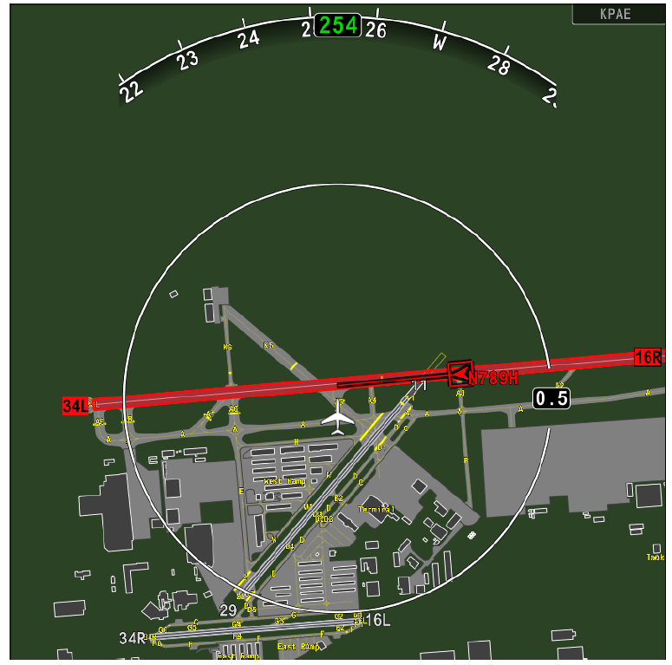
Figure 7. Conceptual Cockpit Display of Surface with Indications and Alerts⁴⁹

Benefit

Accurately quantifying benefits in terms of avoidance of hull loss and fatalities is difficult because fortunately there have been few actual runway incursion accidents, however the projected growth in aviation traffic activity coupled with the documented increase in the rate of runway incursion incidents warrant aggressive preemptive action. Initiating rulemaking for runway incursion awareness systems would follow the precedent set with the regulatory action taken for near-mid-air-collisions that mandated TCAS, which according to the Notice of Proposed Rulemaking-Final Rule was warranted because it contributed to an overall enhancement of airplane safety and utility and promoted and enhanced public confidence in, and utilization of the U.S. air transportation systems.⁵⁰ In the absence of substantial mid-air collision accident data the FAA used various mathematical models, based on the few actual accidents, to project and valuate future mid-air collisions. Furthermore, the FAA acknowledged that public confidence was difficult to quantify, however the qualitative nature of the benefits derived from flight deck equipage of TCAS, based on NMAC incidents and not accidents, did not render it any less of a significant factor in determining to proceed with TCAS rulemaking action.⁵¹ Although few in number, runway incursion accidents have been some of the costliest and of highest public interest in aviation history (Table 3). The benefits derived from flight deck equipage of RIAS, based on runway incursion incident data merged with mathematically modeled projected runway accidents, provide sufficient basis to proceed with RIAS rulemaking action.

Table 3
High Profile runway incursion accidents
Year | Location | Airline/Flight | Aircraft | Fatalities
2006 | Lexington KY, USA | Comair 5191 | CL-600 | 49
2001 | Milano Linate, Italy | SAS 686/ BizJet | MD-87,Cessna Citation II | 118
1991 | Los Angeles, CA, USA | USAir 1493/ SkyWest 5569 | B-737, Metroliner | 34
1977 | Tenerife, Canary Islands | KLM 4805/ PanAm 1736 | B-747, B747 | 583

Conclusion

The well-intentioned efforts over the last decade to reduce runway incursions have encompassed the entire hierarchy of risk controls, however runway incursions have not shown a significant decrease. The NTSB accident report for Comair Flight 5191 stated the following regarding cockpit moving map displays for surface navigation and cockpit runway alerting systems:

These technologies have not been mandated despite the demonstrated safety benefits. These technologies need to be considered in the same category as existing technological interventions such as the traffic alert and collision avoidance system (commonly referred to as TCAS) and EGPWS. Therefore, the Safety Board believes that the FAA should require that all 14 CFR Part 91K, 121, and 135 operators install on their aircraft cockpit moving map displays or an automatic system that alerts pilots when a take-off is attempted on a taxiway or a runway other than the one intended (p. 94)⁵²

Since the 2006 Comair Flight 5191 runway incursion accident the rate of runway incursions has steadily increased as well as the overall number of runway incursions and the number of ” pilot deviation” type runway incursions. Precedents from regulation-based technological solutions for controlled-flight-into-terrain and near mid-air collisions, indicate that the FAA goal of a 10% runway incursion reduction in 5 years (FY 2013) is modest for a hazard of this severity and high public. Technologies for runway incursion awareness systems (RIAS), that include a situational display with integrated distinct visual and aural alerts, are technically mature with a range of alternatives for the full spectrum of airspace users from small airplanes and rotorcraft to large transport category airplanes. Achieving significant runway incursion reductions lie in the synergy of mature technology and cockpit procedures that are codified in Federal Aviation Regulations (FAR) for mandatory installations of runway incursion awareness systems (RIAS).

¹ Federal Aviation Administration [FAA] (2009a). FAA Flight Plan 2009-2013 accessed from http://www/faa.gov/about/plan_reports/media/flight_plan_2009-2013.pdf ² Federal Aviation Administration [FAA] (2004). FAA Flight Plan 2004-2008 accessed from http://www/faa.gov/media/FAA_Flight_Plan.pdf ³ Federal Aviation Administration [FAA] (2010). FAA NextGen Implementation Plan accessed from http://www/faa.gov/about/initiatives/nextgen/media/NGIP_3-2010.pdf. ⁴ National Transportation Safety Board [NTSB] (2010). NTSB Most Wanted List accessed from http://www.ntsb.gov/recs/brochures/MostWanted_2010.pdf ⁵ European Aviation Safety Agency [EASA] (2009). Annual Safety Review accessed from http://www.easa.eu.int/communications/docs/annual-safety-review/2009/RLY_EASA_Annual_101124.pdf ⁶ Federal Aviation Administration [FAA] (2009b). National Runway Safety Plan 2009-2011 accessed from http://www/faa.gov/airports/runway_safety /news/publications /media/ RunwaySafetyReport-kh10-plan.pdf. ⁷International Civil Aviation Organization [ICAO] (2007). Manual on the Prevention of Runway Incursions). accessed from http://www.icao.int/fsix/_Library\ Runway%20 Incursion%20Manual-final_full_fsix.pdf ⁸ FAA, 2009b ⁹ ICAO, 2007 ¹⁰ Ibid ¹¹ FAA, 2009b ¹² Ibid ¹³ Flight Standards Information Management Systems [FSIMS] (2007). FAA Order 8900.1 accessed from http://fsims.faa.gov ¹⁴FAA, 2009a ¹⁵EASA, 2009 ¹⁶European Organization for the Safety of Air Navigation [EUROCONTROL] (2006). European Action Plan for the Prevention of Runway Incursions accessed from http://www.eurocontrol.int/runwayincursion ¹⁷ Ground Proximity Warning Systems (GPWS), 39 Fed. Reg. 44439-44440 (1974) (to be codified at 14 C. F. R. pt 121, 125, and 129 ¹⁸ Terrain Awareness and Warning Systems (TAWS), 65 Fed. Reg. 16736-16756 (2000) (to be codified at 14 C. F. R. pt 121, 125, and 129 ¹⁹ Traffic Alert and Collision Avoidance System (TCAS), 52 Fed. Reg. 32268-32277 [1987a] (to be codified at 14 C.F.R. pt. 1, 91, 121, 125, 129, and 135) ²⁰Traffic Alert and Collision Avoidance System (TCAS), 14 C.F.R. pt. 121.358 (1987b) ²¹Traffic Alert and Collision Avoidance System (TCAS), 14 C.F.R. pt. 135.180 (1987c). ²²Research and Innovative Technology Administration [RITA] (2010). Table 2-15: Number of Pilot-Reported Near Midair Collisions (NMAC) by Degree of Hazard accessed from http://www/bts.gov/ publications/ national_transportation_statistics /html/table_02_15.html ²³GPWS, 1974 ²⁴ Ibid ²⁵ TAWS, 2000 ²⁶ GPWS, 1974 ²⁷ Terrain Awareness and Warning System (TAWS), 14 C. F. R. pt. 121.360 (1974a). ²⁸ Terrain Awareness and Warning System (TAWS), 14 C. F. R. pt. 121.360 (1974b) ²⁹ Breen, B. C. Controlled flight into terrain. IEEE AES Systems Magazine, (1999): 19-24. ³⁰ FAA, 2009a ³¹ FAA, 2004 ³² National Transportation Safety Board [NTSB] (2007). Accident Report NTSB/AAR-07/05 PB2007-910406 accessed from http://ntsb.gov/publictn/2007 /AAR005.pdf. ³³ Federal Aviation Administration [FAA] (2007a). Call to Action. accessed from https://employees.faa.gov/org/linebusiness/ato/news/headquarters/story/ index.cfm? newsID=51669 ³⁴ Ibid ³⁵ Stolzer, A.J., Halford, C.D., & Goglia, J. J. (2008). Safety Management Systems in Aviation (pp. 20-21). Burlington, VT: Ashgate Publishing Company ³⁶International Civil Aviation Organization [ICAO] (2008). Safety Management Manual (SMM) accessed from http://www.icao.int/fsix/_Library/SMM-9859_1ed_en.pdf ³⁷Federal Aviation Administration [FAA] (2007b). Obtaining Design and Production Approval of Airport Moving Map Display Applications Intended for Electronic Flight Bag Systems. Advisory Circular (AC) 20-159 accessed from http://rgl.faa.gov /Regulatory_and_Guidance_Library/rgAdvisoryCircular.nsf/list/AC%2020-159/$FILE/AC%2020-159.pdf ³⁸ Federal Aviation Administration [FAA] (2007c). Use of Class 1 or Class 2 Electronic Flight Bag (EFB). Advisory Circular (AC) 91-78 accessed from http://www.airweb.faa.gov/Regulatory_and_guidance_Library/ rgAdvisoryCircular.nsf/0/EB15B0C685650A0486257321006B3B8C?OpenDocument&Highlight=91-78 ³⁹Air Line Pilots Association International (2007). Runway Incursions: A Call for Action accessed from http://www.alpa.org/portals/alpa/runway safety/RunwayIncursionwhitepaper.pdf ⁴⁰ NTSB,2007 ⁴¹ ICAO,2007 ⁴² FAA,2009b ⁴³Federal Aviation Administration [FAA] (2003). Guidelines for the Certification, Airworthiness, and Operational Approval of Electronic Flight Bag (EFB)Computing Devices. Advisory Circular (AC) 120-76A accessed from http://www.airweb.faa.gov/ Regulatory_and_guidance_Library/rgAdvisoryCircular.nsf/0/ b5de2a1cac2e1f7b86256ced00786888/$FILE/AC%20120-76A.pdf ⁴⁴FAA,2009b ⁴⁵Honeywell (2010). SmartRunway/SmartLanding Functions of the Enhanced Ground Proximity Warning System. Honeywell Drawing Number 060-4564-001 May 22, 2009 accessed from http://www51.honeywell.com/aero/ common/documents/egpws-documents/raas-documents/SmartRunway_ SmartLanding_description.pdf ⁴⁶Boeing (2010). 777-200/-200LR/-300/-300ER/F Flight Crew Operations Manual ⁴⁷Jones, D. R., Prinzel, L. J. (2006). Runway Incursion Prevention for General Aviation Operations. Proceedings of the 25th Digital Avionics Systems Conference. ⁴⁸ Jones, D.R., Prinzel, L.J., Otero, S.D., & Barker, G. D. (2009). Collision Avoidance for Airport Traffic Concept Evaluation. Proceedings of the AIAA/IEEE 25th Digital Avionics Conference ⁴⁹Ibid ⁵⁰ Traffic Alert and Collision Avoidance System (TCAS), 54 Fed. Reg. 940-951 [1989] (to be codified at 14 C.F.R. pt. 1, 91, 121, 125, 129, and 135) ⁵¹Ibid ⁵²NTSB, 2007

