Long Distance Investigations
Thorkell Agustsson MO4852
AAIB – Iceland

Thorkell is working as an Air Accident Investigator for the Rannóknarnefnd flugslysa (RNF), otherwise referred to as the Aircraft Accident Investigation Board of Iceland (AAIB), for nine years. He spent five of those years (2005-2010) with the AAIB working as a Chief Investigator while his colleague temporarily held a position at ICAO. Thorkell has been involved in nearly 250 investigations with over 150 of those functioning as an Investigator in Charge (IIC). Several of the investigations he has been taken place in countries around the world. Thorkell has a M.Sc. degree in engineering as well as diploma of mechanical engineering and industrial engineering. His M.Sc. diploma has the title of “International technology management”.

The presentation
Thorkell’s presentation covers his experience of an investigation of Boeing 747-300 accident that occurred about 5.400 miles from his office. Thorkell experienced the investigation as quite smooth and straight forward, thanks to the well known investigation rules and guidelines within the aviation investigation world.
The Icelandic investigation group is relatively a small body containing two investigators, three board members (plus three deputies) and a part time employed secretary.
On the 25th of Marc 2008, Thorkell got a phone call, at his office in Reykjavik, from the operator Air Atlanta Icelandic where the operator was notifying an accident. One of their aircraft TF-ARS (Boeing 747-300), a passenger plane leased to Saudi Arabian Airlines had caught fire, immediately after landing at Zia international airport in the capital of Bangladesh. All 307 passengers and 18 crew members were safely evacuated.
The first hours and days after the accident were used for several conference calls between the states involved. The conference calls were basically about the protocols of the investigation as well as the preparation and planning of the on-site investigation (all contact info went quite smooth from the very first hour). The aviation authorities in Bangladesh requested the authorities in Iceland to conduct the investigation which Iceland AAIB accepted and did send the Investigator in Charge (IIC) to the accident site.
The Icelandic IIC traveled to Bangladesh along with advisers from the operator and Icelandic Civil aviation authorities. The accredited representative as well as advisors from the state of design/manufacturer of the engines and the aircraft planned the traveling as well to the site. In that way, even though only one investigator was sent from the small investigation unit in Iceland, there were still a number of specialists traveling to the site in order to assist on the investigation.
When arriving at the site the investigation was formally handed over to Iceland authorities and further investigation process was made possible for a “well ordered” investigation as well as proper facilities for the interviews. During the on-site investigation the investigation team found out that the fire was caused by a fuel leak from one of the main fuel line coupling of engine nr. 3. This coupling was last maintained at MAS Engineering & Maintenance Division in Kuala Lumpur, Malaysia.
When leaving the accident site, the authorities in Bangladesh made it possible to transport the flight recorders in proper way (smoothly through customs authority, special place in the aircraft etc.) The flight was a direct flight to London UK where the AAIB UK assisted in processing the recorders (immediately).
For this investigation, a number of states were involved: Bangladesh as a state of occurrence, Malaysia as a state where the maintenance was made, UK as the state who made the maintenance agreement (with MAS in Malaysia) in accordance with EASA 145, Saudi Arabia as state where the aircraft was leased to, USA as the state of manufacturer, and Iceland as a state of the operator. For the continued investigation, the IIC were located in Iceland with contacts located eight time zones to the west and eight time zones to the east.
The IIC experience is in the way that even for a small investigation body like in Iceland and the distance between interested states is quite long (other end of the world) the investigation process is quite the same as for shorter distance due to the fact that the investigation process is quite standard and well known worldwide.

The accident
The flight of TF-ARS was a scheduled flight from Medina (Saudi Arabia) to Dhaka, (Bangladesh). During the landing roll at Zia International Airport at Dhaka, the strut/engine area No. 3 caught fire. The aircraft came to a rest on a taxiway at the end of the runway where all 307 passengers and 18 crew members evacuated through emergency exits. The fire department at Zia International Airport managed to extinguish the fire but the aircraft was later evaluated beyond economical repair.
A fuel leak from a fuel line coupling at strut No. 3 was determined as the cause of the fire/accident. The coupling was incorrectly assembled most probably during the aircraft’s last “C-check”, completed 6 months prior to the accident.
According to the commander, the flight from Medina and the landing at Dhaka was uneventful. During the landing roll, approximately 50 seconds after touchdown, the flight crew received a call from the tower controller where the tower controller inquired whether the aircraft was under control. The flight crew responded to the call by stating that the aircraft was completely under control and asked what the problem seemed to be. The controller then informed the flight crew that fire was observed at the right wing area. At this point the Aerodrome Fire Operator had already activated the fire fighters as well as the rescue team. As soon as the controller had informed the flight crew about the fire, the flight crew received a No. 3 engine fire alarm. The co-pilot immediately discharged the first engine fire bottle and the flight crew requested fire fighter assistance and shut down all engines. The co-pilot waited 20 seconds until the second fire bottle was discharged. At this time the commander called the senior cabin attendant to the flight deck using the public address system (PA). This command was followed by a command to the cabin crew to remain seated. The commander informed the senior cabin attendant of the situation and instructed him to evaluate the situation and to evacuate the passengers if necessary. The senior cabin attendant went back down to the main deck and saw the smoke and the fire through the windows. He then commanded the cabin crew as well as passengers, by using a megaphone, to evacuate the aircraft.

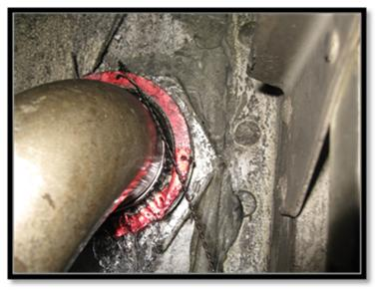
During the on-site investigation, a fuel leak was discovered at one of the main fuel line couplings (Figure 1). The leak was found where the main fuel line is coupled to the front spar for engine No. 3. By moving the fuel line a little by hand, a fuel leak was observed (Figure 2).
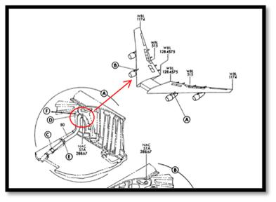
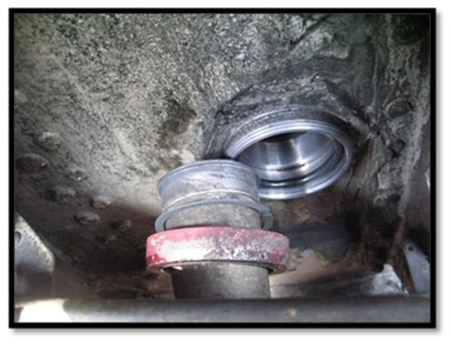
Figure 1
Figure 2
After opening the coupling it was discovered that it was incorrectly assembled where one of the two retaining rings was missing (Figure 3) and the O-ring was in the wrong position (not on the fuel line). Therefore the O-ring was probably not sealing as it should when correctly installed. Figure 4, shows a comparable coupling in the front spar. In Figure 4, the O-ring is correctly installed on the fuel line, i.e. between two retaining rings.
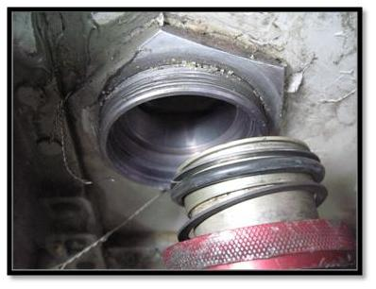

Figure 4
Figure 3
The Icelandic Aircraft Accident Investigation Board (IAAIB) considered that an unclear instructions in the aircraft maintenance manual (AMM) to be a contributing factor of the incorrect installation.
Following the investigation the aircraft manufacturer made changes to the maintenance manual in order to avoid such incorrect installation.

