Helicopter Design for Maintainability: Guidelines and Recommendations
by Andrés Serrano Velásquez, Guilherme Conceição Rocha (KONATUS) and Donizeti de Andrade (ITA)

Andrés Serrano Velásquez graduated in Aeronautical Engineering and has a Master’s degree in Aviation Safety and Continued Airworthines. He joined KONATUS in 2010 and since then he has worked as an aviation safety consultant, responsible for the elaboration of guidelines for the implementation of a integrated management system in aerospace organizations.

Guilherme Conceição Rocha graduated in Mechanical and Aeronautical Engineering and has a Master’s degree in and Aeronautical Engineering from Technological Institute of Aeronautics (ITA). He is the KONATUS founder and Director. He has ten years’ aerospace industry esperience in the areas of system engineering, customer support, reliability and maintenance. Currently a consultant at DCA-BR in the areas of hydro-mechanical systems, operational safety and environment management.

Donizeti de Andrade is a Professor at the Technological Institute of Aeronautics (ITA) in Brazil. He has an educational background in Aeronautical Engineering and is Master in Aeronautical Engineering from the Technological Institute of Aeronautics, ITA (1983 and 1987, respectively). He also earned a Master of Science in Aerospace Engineering and a Doctor of Philosophy degrees from the Georgia Institute of Technology, Georgia Tech (both in 1992). In 2002 he received a Certificate of Specialist in Aviation Safety issued by the University of Southern California (USC). He also earned an MBA from the partnership ITA and the Superior School of Propanda and Marketing (ESPM) in 2003. He is the main responsible of the conception, focal point and coordinator of the Professional Master in Aviation Safety and Continued Airworthiness Course (MP-Safety), offered by ITA, whose first offer was in 2008.

Abstract
The acceleration of the technological progress often begins with a greater emphasis on research, design and development to produce more competitive products. This work considers the development of rotorcraft projects, as its object of study. The focus is on the applicable maintainability aspects, identifying the importance of establishng guidelines and recommendations with emphasis in maintainability to support the designer in predicting the maintainability of helicopters, indicating the design vulnerabilities that can affect safety during maintenance activities. From the paper, it becomes evident that the maintainability allows, through qualitative attributes and metrics, the establishment of standards to be considered in the design phases.
Introduction
Currently, safety, functionality and maintainability are high priorities for the designers during integration of components developed in composite materials for new helicopter design concepts. They put in practice advantages of these materials, especially those that find application in the airframe of commercial and military aviation due to the high performance, strength, stiffness, better fatigue life, corrosion resistance and low weight, among other features.
During the development stages of a project, as shown in Figure 2, the requirements of maintainability of the new product should be:
- Provide and include in documentation a plan for a particular program or project;
- Specify the level of applicability of product;
- Included in the iterative processes of functional analysis, allocation, trade-off, optimization, synthesis and selection of components;
- Measure in terms of adaptation through testing and product evaluation.
Figure 1 – Maintainability requirements (BLANCHARD, 1995)
As a motivation for this work, it is important to consider that according to data from the National Civil Aviation Agency (ANAC) of Brazil the fleet of helicopters in the contry had an increase of 58.6% in the last ten years. However, as shown in the Figure 2 one notes a slight increase in accidents involving this type of aircraft, from 2006 the number of helicopter accidents has remained stable.
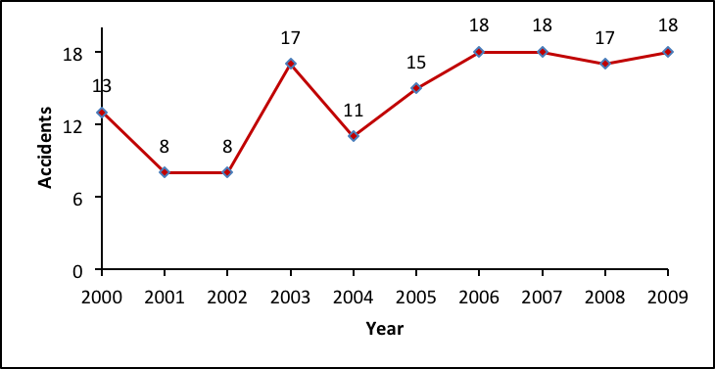
Figure 2 – Accidents involving helicopters in Brazil 2000 to 2009 (ANAC, 2009)
Figure 3 shows the percentage of contributing factors to helicopters accidents in Brazil, with respect to maintenance, the percentage is 20% and the material factor, which is the area of operational safety, design and manufacturing have respectively 15.2% and 5.7%, these are highlighted because they deal with relevant aspects in order to contribute to the reduction of catastrophic events.
Figure 3 – Percentage of factors related to helicopter accidents in Brazil 2000 to 2009 (CENIPA, 2010)
In this context, this paper aims to establish guidelines and recommendations with focus on maintainability for helicopters design and improve safety in maintenance activities.
Knezevic (1993) defines maintainability as an intrinsic feature of a product, associated with its ability to recover for the service to be held required maintenance, as specified by the manufacturer.
According to Dhillon (1999), probably the greatest effort to implement a maintainability program comes from the aircraft industry, where the availability of an aircraft has a major impact on an airline to meet the market needs.

The maintainability program
A maintainability program should contribute to achieve the following maintenance goals:
- Improve the operational capacity;
- Reduce the need for human resources and define whether the system can be operated and maintained;
- Reduce life cycle costs;
- Ensure that the requirements of maintainability are properly demonstrated and assessed during the development of aircraft’s operational tests and evaluation.
- Provide essential data for management, in order to guarantee that the results of the evaluation of maintainability are presented in a form suitable to support the decision-making process.
It is important to recognize that these goals are interconnected and affect both the operational effectiveness and costs.
In addition to the physical characteristics of the project, staff and human factor considerations involved in maintenance activities are important. Those considerations include mechanic experience, training required skill level, necessary supervision, supervision available and team work.
Helicopter systems affected by to errors in maintenance activities are shown in Figure 4. The index establishes the main rotor assembly as the most critical helicopter system present in 32% of cases of accidents and incidents investigated by Rashid (2010).
This system also involves a significant amount of the total hours devoted to maintenance activities.
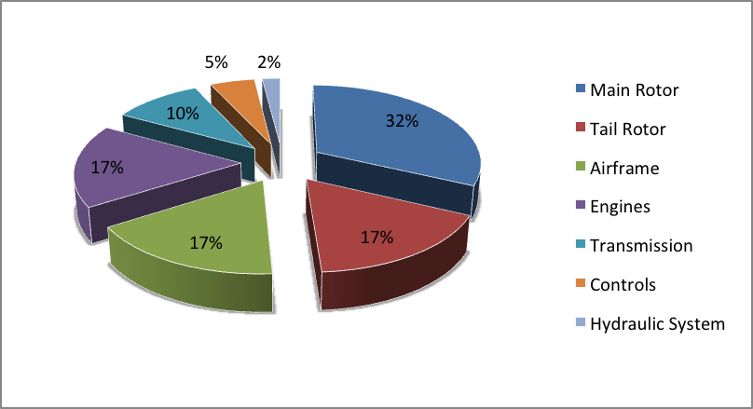
Figure 4 – Helicopter systems involved in safety occurrences (RASHID, 2010)
Product life cycle phases
The product life cycle, shown in Figure 5, is characterized by four phases, namely: concept development, validation, production and operation. Dhillon (1999) says that maintainability is associated with each of these phases and that an effective program incorporates maintainability as a dialogue between the user and the manufacturer during the entire life cycle of the product.
Figure 5 – Product life cycle phases (DHILLON, 1999)
Conceptual development phase, during this phase, the main maintainability task is to determine the product requirements effectiveness and, for the purpose of the operation, set the policies and necessary continued airworthiness. The effectiveness of the product is defined by Dhillon (1999) as the probability that the product can successfully meet an operational demand within a defined range, being used according to design specifications.
Validation phase, the maintainability management tasks during this phase are directed to:
- Develop a maintainability program that satisfy contractual requirements.
- Develop a test plan and maintainability demonstration.
- Determine the specific maintainability requirements, reliability and effectiveness of the product.
- Develop incentives or sanctions maintainability.
- Coordinate and monitor maintainability efforts throughout the company.
- Develop policies and maintainability procedures, both for the validation phase as a subsequent engineering effort.
- Provide assistance in maintenance engineering areas such as analysis of the implementation of maintenance, policy development and logistics requirements for the effectiveness of the product.
- Prepare a document data collection, analysis and evaluation.
- Participate in design review.
Production Phase, during this phase the maintainability includes the process of production monitoring, analysis of trends of the adverse effects on the maintainability requirements and maintenance assessment of all proposals for change with respect to their impact on the maintainability. It ensures the eradication of any discrepancies that may decrease maintainability and participation in the development of controls to prevent changes, errors, and other problems that may affect the maintainability.
Operation phase, the maintenance, training, reconditioning, material availability requirements and product characteristics become evident. The phase is probably the most significant because the product offers the true cost-benefit and support logistics. In this phase data can be collected from the experience of the operation of the product to be used in future applications of maintainability in new projects.
Maintenance is essential to aviation safety and continued airworthiness; inadequate maintenance, incorrectly performed tasks, lack of oversight or omission in parts due to human error contribute increase accidents and incidents aviation.

According to Hobbs (2008), many other threats to aviation security, involving for example, maintenance personnel errors, may be more difficult to detect, and have the potential to remain latent, affecting the reliability of the aircraft for long periods of time.
Maintainability and Human Factor
It was not until the 1950s that the attention in the human factors have focused on the impact of the maintenance characteristics of product design.
According to Dhillon (1999), the maintainability depends on actions of maintenance personnel and involves the interaction between people and machines. If during the product design failure related to human factors are present, they can influence the increase of maintenance errors and reduced the product effectiveness.
Hobbs (2008) afirmed that maintenance personnel rarely have the opportunity to influence the product design and project whose attributes imply bad maintainability maintenance problems. Examples of projects with poor maintainability include:
- Components that are difficult to access, as shown in Figure 6, where the components have to be disconnected to allow access.
- Vision obstructions.
- Proceedures that require levels or accuracy of strength that are difficult to obtain.
- Nearby systems, which are difficult to distinguished from each other, raising the possibility of confusion.
- Components that can be installed in wrong position.
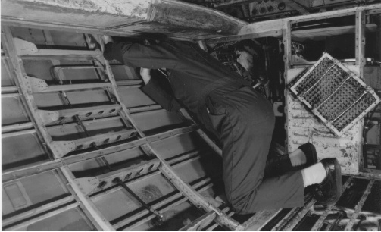
Figure 6 - Accessibility difficulties are a common feature in maintenance (HOBBS, 2008)
According to Clive (2007) the error in maintenance is a normal factor in maintenance operations that can be addressed during the design process to ensure that the error does not lead to compromise safety
The product maintainability design must also consider the effects that the environment work can have on the maintenance performance. Factors such as temperature, lighting, humidity, can seriously affect the skills.
The biggest impact on the product maintenance characteristics is in the design phase; consequently, the challenge is to anticipate and quickly precise the maintainability attributes in the project initial phase, when changes and modifications are possible without increased time or cost.
Guidelines and recommendations
Guidelines and recommendations should be established to the designer of the future product development to include the relationship of physical attributes such as simplicity, accessibility, modularity, interchangeability, standardization, testability and diagnostic techniques compatible with product.
Guidelines are considered as advisory guidelines for designers, aimed at ensuring the maintainability of the product and they are not intended to serve as a rigid set of requirements. Failure to meet any of these guidelines can could jeopardize the operational safety project.
On the other hand, the recommendations represent suggestions that increase the level of maintainability and try to reduce the life cycle cost. Failure to meet these recommendations does not directly impact the project’s operational safety, however, it affects the financial part.
To systematize these guidelines and recommendations, it is adopted the code XXXX-Y-ZZ, according to the model presented in Table 1 and the qualitative attributes in Table 2.
Table 1 – Code of guidelines or recommendations (SERRANO, 2010)
Legend | Meaning
XXXX | first four letters of the attribute in capital
Y | guideline (G) or recommendation (R)
ZZ | serial number
Table 2 – Maintainability qualitative attributes (SERRANO, 2010)
Legend | Maintainability qualitative attributes
SIMP | Simplicity
ACCE | Accessibility
MODU | Modularity
INTE | Interchangeability
STAN | Standardization
TEST | Testability and diagnostic techniques
ERGO | Ergonomics
REPA | Reparability
DISP | Availability
Guidelines related to the attribute simplicity
Some guidelines that help the designer to design a product with characteristics simplicity are:
SIMP-G-01 Consider simpler alternatives for designing the product;
SIMP-G-02 Reduce the number of parts and minimize the mechanical adjustments;
SIMP-G-03 Making a consolidation and sequential logic functions;
SIMP-G-04 Improving the access of items that are regularly maintained;
SIMP-G-05 Avoid the use of parts or materials that have caused problems of reliability and maintainability in earlier projects; and
SIMP-G-06 Streamline maintenance processes by providing components that require little maintenance, preventive actions or scheduled.
Recommendations related to the attribute simplicity
Some design recommendations related to the attribute simplicity are:
SIMP-R-01 Consider elements for quick disconnection to minimize the time of replacement or maintenance;
SIMP-R-02 Simplify the diagnostic techniques;
SIMP-R-03 Determine whether there is need for special tools or if it can be eliminated or replaced by another common use tool.
Guidelines regarding accessibility attribute
Some guidelines that help the designer to define a product with the attribute accessibility are:
ACES-G-01 Design the access in order to allow maximum convenience in carrying out maintenance tasks;
ACES-G-02 Design the access at a safe distance from moving parts;
ACES-03-D Prevent access or inspection panels near the air intake duct of the engine, because they can be sucked into the engine;
ACES-G-04 Design access free of edges that may cause injury to maintainers in the activities of inspection, maintenance or repair;
ACES-G-05 Ensure that the location of access allows direct access to parts or components that require maintenance without removing other items;
ACES-G-06 Ensure that the location of the access point is compatible with the work or equipment to be used for maintenance; and
ACES-G-07 Ensure that access will be effective under normal installation of parts.
Recommendations related to the attribute accessibility
Some design recommendations related to the attribute accessibility are:
ACES-R-01 Avoid, if possible, using access riveted or welded to the fuselage, or other panels or access requiring removal of structures;
ACES-R-02 Identify all access panels for quick installation;
ACES-R-03 Avoid, if possible, using screws holding the doors when the inspections are frequent;
ACES-R-04 In the assembling of two consecutive components, start with that that requires more attention leaving the one which needs less attention to be assembled after;
ACES-R-05 Locate access doors away from moving parts that present a potential threat, if the danger can not be avoided, identify the access door alerting maintenance personnel of that danger; and
ACES-R-06 Find hydraulic reservoirs to be visually accessible for refueling. If the maintenance personnel can not see the fluid level, this can overflow during refueling and damage nearby components.
Guidelines related to the attribute modularity
Some guidelines that help the designer to define a product with the attribute modularity are:
MODU-G-01 Divide the product into modular units, based on the criterium of having them as uniform in size and shape as possible;
MODU-G-02 Design the components so that in most cases a single person can handle and replace any defective component without difficulty;
MODU-G-03 Minimize interconnections between neighboring modules and make efficient use of space;
MODU-G-04 Design control levers and linkages that allow easy disconnection of the components, so that the replacement of components is simple;
MODU-G-05 Design, whenever possible, units small and light enough for maintenance personnel to be able to handle and load;
MODU-G-06 Design the modules to allow greater ease in operational tests, when they are removed from products;
MODU-G-07 Design each module in a way that they can be inspected independently.
Recommendations related to the attribute modularity
Some design recommendations related to the attribute modularity are:
MODU-R-01 Design the equipment (electrical or mechanical) in modular units as much as possible;
MODU-R-02 Design modular units with components optimized for a specific function or multiple functions rather differently;
MODU-R-03 Adopt an integrated approach to product development, simultaneously considering the problems of component design, materials and modularization.
MODU-R-04 Consider the application of the concept of modularity for major components and subsystems.
Guidelines related to the attribute interchangeability
Some guidelines that help the designer to define a product with the attribute interchangeability are:
INTE-G-01 Ensure that when an individual is the interchangeability feature of the project, also there is an equivalence of functional interchangeability;
INTE-G-02 Avoid the differences in size, shape, assembly and other features;
INTE-G-03 Avoid installations where dangerous conditions can be created as a result of a possible connection failure;
INTE-G-04 adapters to provide physical interchangeability possible in situations where the functional interchangeability is possible, and
INTE-G-05 Identify all the parts as interchangeable / identical components.
Recommendations related to the attribute interchangeability
Some design recommendations related to the attribute interchangeability are::
INTE-R-01 Use screws and other fasteners to all same size or in some cases the same for a particular piece of equipment;
INTE-R-02 Provide sufficient identification on signs or labels and technical manuals that allow the user to decide if two similar parts are interchangeable, and
INTE-R-03 Provide a maximum number of interchangeable parts.
Guidelines related to standardization attribute
Some guidelines that help the designer to define a product with the attribute standardization are:
STAN-G-01 Reduce the number of different brands and models;
STAN-G-Prevent or minimize the use of special manufacturing techniques;
STAN-G-03 Maximize the use of common parts in different outfits, and
STAN-G-04 Make use of the SI International System of measures when necessary.
Recommendations related to the attribute standardization
Some design recommendations related to the attribute standardization are:
STAN-R-01 Ensure that the parts with the same identification number (part) of the manufacturer to be directly and completely interchangeable with respect to the installation and performance;
STAN-R-02 Use, whenever possible, share identical in identical outfits, and
STAN-R-03 Standardize the use of parts, screws, connectors, cables, lines, among others.
Guidelines related to the attribute testability and diagnosis
Some guidelines that help the designer to define a product with the attribute testability and diagnostics are:
TEST-G-01-Consider the level of repair as part of the analysis of testability;
TEST-G-02 Design the test points accessible without removing the system of modules and components;
TEST-G-03 Ensure the accessibility of external test points;
TEST-G-04 Identify each test point with an appropriate name or symbol;
TEST-G-05 Identify each test point with the sign of tolerance or limits that should be measured;
TEST-G-06 Find the test points in order to reduce the search time, i.e, near the main access openings, and
TEST-G-07 Protect test points properly.
Recommendations related to the attribute testability and diagnosis
Some design recommendations related to the attribute testability and diagnostic are:
TEST-R-01 Design for testability simultaneously with the design of the equipment;
TEST-R-02 Consider solutions BIT / BITE;
TEST-R-03 to ensure the testability of the product evolution from the information analysis of tests and experiments;
TEST-R-04 Plan the points test for compatibility with the levels of maintenance skills;
TEST-R-05 Use the FMEA methodology as part of the analysis of testability, and
TEST-R-06 Develop a format step by step instructions for use of test equipment.
Guidelines related to the attribute Ergonomics
Over the years, professionals working in maintenance area have developed several guidelines for designers, considered useful for improving related safety. Some guidelines that help the designer to define a product with the attribute ergonomics are:
ERGO-G-01 Pay close attention to typical human behavior, eliminate or reduce the need for special tools;
ERGO-G-02 Develop projects / processes so that the probability of maintenance error is minimized;
ERGO-G-03 Develop projects with easy access to parts requiring maintenance are easy to check, replace or remove;
ERGO-G-04 Incorporate effective projects to prevent damage or injury in the event of a failure, and
ERGO-G-05 Install adequate locks to block access to dangerous places and provide protective effective against moving parts.
Recommendations related to the attribute ergonomics
Some design recommendations related to the attribute ergonomic are:
ERGO-R-01 incorporate appropriate devices and measures for early detection or prediction of all types of potential failures so that maintenance can be performed before actual failure with a reduced risk of danger.
Conclusions
Products within complex systems designs, such those in the aviation industry, requires management of the maintainability concepts to support the engineering processes, maintenance, authority safety requirements and requirements associated with the continued airworthiness.
The establishment of guidelines and recommendations with focus on maintainability helps to reduce the number of operational problems related with maintenance activities, and necessary actions to maintain or restore the product to an operational condition after a failure, improving the availability, and minimizing life cycle costs. Maintainability requirements should be incorporated early in the aircraft design.
Maintainability should be intrinsically linked to human factors, the designer has an understand human capabilities and limitations (vision, hearing, perception, memory, fatigue, etc) and translate them into designs that optimize the maintenance process, increase the performance and avoid equipment damage, personal injury or human error.
Refrerences
AGÊNCIA NACIONAL DE AVIAÇÃO CIVIL (ANAC). Relatório Anual de Segurança Operacional 2009. www.anac.gov.br/arquivos/pdf/RELATORIO_2009.pdf
BLANCHARD, B.S. VERMA, D.; PETERSON, E.L. Maintainability: a key to effective serviceability and maintenance management. New York : John Wiley & Sons, 1995.
CENTRO DE INSVESTIGAÇÃO E PREVENÇÃO DE ACIDENTES AERONÁUTICOS (CENIPA). Panorama estatístico da aviação civil Brasileira para 2000 a 2009. www.cenipa.aer.mil.br/cenipa/paginas/normas/Panorama2000_2009.pdf.
CLIVE, N. Maintainability design principles for aircraft maintenance error avoidance. Communications in Dependability and Quality Management an International Journal, v.10, n.4, p. 31-40, Dec. 2007.
DHILLON, B.S. Engineering maintainability. Houston : Gulf Publishing Company, 1999.
KNEZEVIC, J. Chief mechanic: the new approach to aircraft maintenance by Boeing. Journal of Quality in Maintenance Engineering, vol. 5, n.4. p.314-324, 1999.
HOBBS, A. An Overview of Human Factors in Aviation Maintenance. ATSB, Australia. 2008. http://www.atsb.gov.au/media/27818/ar2008055.pdf
SERRANO, Andrés. Estabelecimento de Diretrizes e Recomendações com Enfoque em Manutenibilidade para o Projeto de Aeronaves de Asas Rotativas. 2011. 149f.
RASHID, H. Human Factors Effects in Helicopter Maintenance: Proactive Monitoring and Controlling Techniques. 2010. 320f. Dissertação (Doutorado) – Cranfield University.

