

Companion’s Program

Tuesday September 13th
Salt Lake Heritage Tour 8:30am-1:30pm

8:15 am Meet in lobby
8:30 am Buses depart
Noon Lunch at Red Butte Gardens
1:30 pm Stroll or take the bus back to hotel

Wednesday September 14th
Wasatch Back Tour 8:30am-4:30pm

8:15 am Meet in lobby
8:30 am Buses depart hotel
Noon Lunch at Homestead Resort
4:30 pm Arrive back at hotel

Times to Remember

Breakfast - Salon F

Monday: 7:30 am – 9:00 am (Tutorial participants only)
Tuesday/Wednesday/Thursday 7:00 am – 8:30 am (All)

Seminar Registration - Cottonwood Foyer

Sunday September 7 4:30 pm - 7:00 pm
Monday September 8 8:00 am - 4:30 pm
Tuesday September 9 7:30 am - 4:30 pm

Social Program for all
Monday September 12th

Welcome Reception – Salon D
6:00 pm - 8:00 pm

Tuesday September 13th

Dinner – La Caille

5.30 pm Meet in Lobby
5:45pm Buses depart
9:15pm First bus starts back to the hotel

Thursday September 15th

Presidents Reception -Ballroom Foyer
6:00 pm – 7:00 pm

Awards Banquet - Salon F
7:00 pm – 10:00 pm

Expected Dress

Technical Program – Business casual [No jeans, please]
Welcome Reception - Jacket & Tie/Cocktail Attire
La Caille – Casual - No jeans, please
Reception/Banquet – Jacket & Tie/Cocktail Attire
Companion’s Program – Casual Attire [No jeans, please]

Break-out Meetings – 4:30

Room Tuesday Wednesday
Deer Valley 1 CSASI GASIG
Deer Valley 11 Unmanned AC
Deer Valley 111 AsiaSASI Corporate Affairs
Solitude International General Aviation
Salon D – E USSASI Cabin Safety
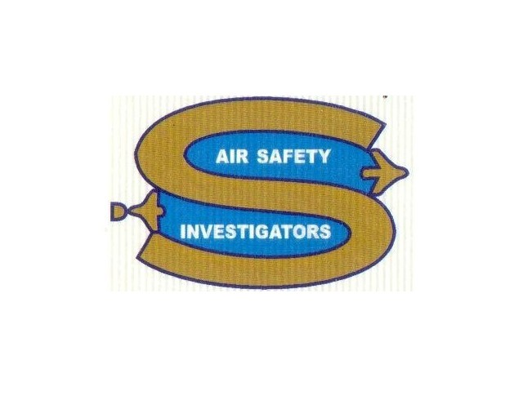

An International Accident Investigation and Prevention Training Seminar
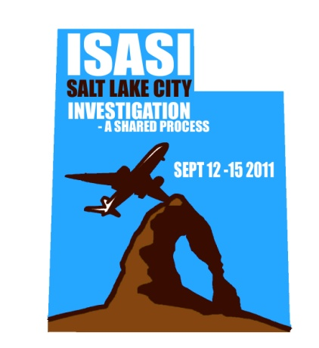

The International Society of Air Safety Investigators

Presents

"ISASI 2011"
Salt Lake City, Utah

September 12-15 2011

“Investigation-
A Shared Process”

Technical Program

Monday Sept 12 – Tutorials – Salon E

8:30 – 12:30
Digital Photography for Accident Site Investigation
Tony Gasbarro – Transportation Safety Board Canada

1:30 - 5:00
Improving Aircraft Integrity from Accident/Incident Analysis Information – Closing the Loop
Dr. David Hoeppner – University of Utah

12:30 – 1:30 pm Tutorial Participant Lunch
Salon F

Plenary Sessions

Tuesday Sept. 13 - Salon D & E

8:30 Seminar Opening
Frank Del Gandio – President ISASI
Dick Stone – Chair ISASI 2011

8:40 Keynote Address
Marcus Costa
Chief, Accident Investigation Section - ICAO

9:00 Rudy Kapustin Scholarship Presentations

10:00 Morning Break

10:30 British Airways B777 Investigation
Robert Carter - UK
Principal Inspector of Air Accidents - AAIB
Chief inspector of Air Accidents - AAIB

11:00 Flight Path Analysis
Major Adam Cybanski - Canada
Directorate of Flight Safety - Canadian Forces

11:30 Questions/Discussion from the floor

Noon Lunch - Salon F

1:30 Using “ASTERIX” in Accident Investigation
Michiel Schuurman – The Netherlands
Senior Investigator Aviation - Dutch Safety Board
Paul Farrell – Ireland
Inspector of Accidents - AAIU

2:00 Who Is Onboard in GA and Air Taxi Accidents?
Bob Matthews - USA
Office of Accident Investigation - FAA

2:30 Preventing the Loss of Control Accident
Patrick Veillette - USA

3:00 Afternoon Break

3:30 Building Partnerships in Unmanned Aviation Systems
Tom Farrier - USA
Chair, ISASI UAS WG

4:00 Questions/Discussion from the floor

4:30 National Society Meetings

Wednesday Sept. 14 - Salon D & E

8:30 Teamwork in the Cause of Aviation Safety
Sébastien David - Léopold Sartorius - France
Safety Investigators – BEA

9:00 Long Distance Investigations
Thorkell Agustsson – Iceland
Chief Inspector, Air Accidents – AAIB

9:30 Smaller Nations & Annex 13
Syed Naseem Ahmed - Pakistan
Aviation Consultant

10:00 Morning Break

10:30 Timeliness, an Investigators Challenge
John Stoop – The Netherlands
Lund University, Sweden
Delft University of Technology, the Netherlands

11:00 Major Investigations, New Thinking Ahead
Bob MacIntosh - USA
Chief Advisor, International Safety Affairs NTSB

11:30 Questions/Discussion from the floor

Noon Lunch - Salon F

1:30 Post-Turbulence Structural Integrity Evaluation
Ray Chang/C. Edward Lan/Wen-Lin Guan – Republic of China

2:00 Analysis of Fuel Tank Fire and Explosion
N. Albert Moussa - USA
BlazeTech Corp.

2:30 Elimination of Aircraft Accidents through Flightdeck Technology
Robert Joslin - USA
Chief Scientific & Technical Advisor
Flight Deck Technology Integration – FAA

3:00 Afternoon Break

3:30 Helicopter Design for Maintainability
Andrés Serrano - Brazil

4:00 Questions/Discussion from the floor

4:30 ISASI Working Group Meetings

Thursday Sept. 15 - Salon D & E

8:30 B-787 Safety Presentation
Thomas Dodt - USA
Chief Engineer - Air Safety Investigation
Boeing Commercial Airplanes

9:00 Human Errors & Criminal Guilt
Yukiko Kakimoto - Japan
Institute of Human Factors

9:30 Pilots’ Cognitive Processes for Making In-flight Decisions under Stress
Wen-Chin Li PhD – Republic of China
National Defence University

10:00 Morning Break

10:30 Human Factors Standardized Procedures
Helena Reidmar – USA
First Officer – Delta Airlines

11:00 “Back to Basics” Still Work?
Mont Smith - USA
Director Safety - ATA

11:30 Questions/Discussion from the floor

Noon Lunch - Salon F

1:00 ISASI Business Meeting (ISASI Members)

1:30 Update on the AF 447 Investigation
BEA - France

2:30 Afternoon Break

3:00 An Investigation Media/Communications Strategy
Ian Sangston – Australia
General Manager ASI – ATSB

3:30 Accident Communication in Today’s Media Environment
Christopher McGregor - France
Head of Accident / Incident Investigation
AIRBUS

4:00 Questions/Discussion from the floor

4:30 Seminar Closing

